Africa Carbon Markets Initiative’s

Status and Outlook Report 2024

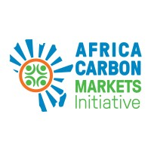

Table of Contents
Forewords 7
Foreword from The Report Sponsors 7
Foreword from ACMI’s CEO 8
Executive summary: The Sponsor's Narrative on African Carbon Markets 9
1. The past year for carbon markets 13
1.1. Key trends in global carbon markets 13
1.2. Key trends in African carbon markets 18
2. From launch to May 2024 for ACMI 24
2.1. ACMI’s standalone chievements and action programmes 24
2.2. ACMI’s progress in tackling key barriers to carbon markets 26
2.3. ACMI’s presence in key events 33
2.4. Lessons learned in the past year 35
3. roadmap for target outcomes over the next 24 months 41
3.1. A revised approach: Mission, value proposition, and roles 41
3.2. Key actions to be taken in the African carbon markets 42
4. A call to action 48
Glossary 50

This report is meant for discussion purposes only and should not be relied on for making decisions without seeking professional advice.

The sponsors of this report, being the Africa Carbon Markets Initiative (ACMI), working with broader partners, are seeking to contextualise the impact carbon markets could have on the African continent. The Report does not endorse any companies, organisations, products or credits included in this report, nor have the sponsors assessed individual companies or projects.

ACMI itself is not a commercial initiative. It aims to build on, supplement and reinforce ongoing efforts towards scaling voluntary, Article 6, and compliance carbon markets on the continent, and not to compete with any existing initiative.

The Report is intended to serve as a convening message to represent the broader carbon markets ecosystem and not individual organisations. The goal is for implementing partners to work together to deliver a continental agenda and with agreement to disclose any potential direct benefits and recuse themselves from any efforts that could directly benefit themselves or their organisations.

On its mission to scaling African carbon markets with integrity, equity, and transparency, the development of this report has involved engaging with over 400 stakeholders, including:

Adrien Sinafasi – Dignité Pygmée
Aeren Young – EY
Albert Nyakujarah – Afreximbank
Alfred Gichu – Kenyan Ministry of Environment & Forestry
Amadou Hott – African Development Bank
Andrew Hedges – Baker McKenzie
Anna Lehmann – Wildlife Works
Annette Nazareth – Integrity Council for Voluntary Carbon Markets
Apollo Tushabe Mukama – TIST
Ash Berman – Climate Action Platform Africa
Azapmo Jean Bertrand - African Union
Bankole Oloruntoba – Nigeria Climate Innovation Centre
Beatrice Karanja – Natural State
Chris Gordon – Conservation Alpha/Natural State
Chris Leeds – Standard Chartered
Deepti Jerath – MIGA
Dorothy Naitore – TIST
Dudu Douglas-Hamilton – Independent consultant
Evans Osano – FSD Africa
Femi Adeyemo – Apex Steel
Fiona Napier – UN Climate Champions
Gillian Caldwell – USAID
Grace Mwangi – Kenya Climate Innovation Centre
Greg Murray – CleanStar Ventures
Helen Brume – Afreximbank
Henrik Axelsson - Odyssey Energy Solutions
Ian Kuwahara – Verra
Isaac Rubayiza – Eastern Africa Alliance
Jacqueline Musiitwa – USAID
James Kairo – Mikoko Pamoja
Jean Paul Adam – United Nations Economic Commission for Africa
Jess Chaplin – Native
Jit Bhattacharya – BasiGo
John Goldstein – Goldman Sachs
João Saraiva – Advisor to Mozambique’s Minister of Economy and Finance
Joshua Ayuo - Kenya Wildlife Conservancies Association
Julius Kamau – JuliusCarbon Ventures
Kelley Kizzier – Bezos Earth Fund
Kevin Kariuki – African Development Bank
Kranav Sharma – Verra
Lanre Shasore – Nigeria Climate Change Commission
Lex Hovani – USAID
Lilian Mwihaki Mugi – Plan Vivo
Lisa Kowitz – USAID
Mark Kenber – VCMI
Martin Hession – European Commission
Maryam Shehu Mohammed – Nigeria Sovereign Investment Authority
Mohamed Farid Saleh – Financial Regulatory Authority, Egypt
Muireann Mageras – Hartree Partners
Nyangena Brian – Verst Carbon
Olivia Adhiambo – Wildlife Works
Olufonso Somorin – African Development Bank
Ousmane Fall Sarr – West African Climate Alliance
Owen Hewlett – Gold Standard
Pearl Nkusi – Rwanda Environment Management Authority
Peter Nyeko – Mandulis Energy
Perumal Arumugam – UNFCCC
Prabhakar Vanam – Kenya Climate Innovation Centre
Rachid Firadi – Ministry of Energy Transition Morocco
Sam Grant – CLASP
Sitoyo Lopokoiyit – Safaricom
Sophie Odupoy – KOKO Networks
Toby Campbell-Colquhoun – Rand Merchant Bank
Tom Lalampaa – Northern Rangelands Trust
Tommy Ricketts – BeZero
Venny Chironga – Zimbabwe Tourism Authority
Vikash Talyan – Gold Standard
Victor Alagbe – Apex Steel
William Perraudin - Risk Control Limited

The Entities Standing Behind and Within ACMI:

The Global Energy Alliance for People and Planet (GEAPP) is an alliance of philanthropy, entrepreneurs, governments in emerging and developed economies, and technology, policy and financing partners. Their common mission is to support developing countries’ shift to a clean energy, pro-growth model that ensures universal energy access and unlocks a new era of inclusive economic growth, while enabling the global community to meet critical climate goals during the next decade. In doing so, as an alliance, GEAPP aims to enable 150 million new jobs, reduce 4 gigatonnes of future carbon emissions, and expand clean energy access to one billion people. With philanthropic partners, Bezos Earth Fund, IKEA Foundation, and The Rockefeller Foundation, GEAPP is working to build the enabling environment, capacity, and market conditions for private-sector solutions, catalyse new business models through innovation and entrepreneurship, deploy high-risk capital to encourage private-sector solutions, and assist just transition solutions.

Sustainable Energy for All (SEforALL) is an international organisation that works in partnership with the United Nations (UN) and leaders in government, the private sector, financial institutions, civil society, and philanthropies to drive faster action towards the achievement of Sustainable Development Goal (SDG) 7 – access to affordable, reliable, sustainable and modern energy for all by 2030 – in line with the Paris Agreement on climate change. SEforALL works to ensure a clean energy transition that leaves no one behind and brings new opportunities for everyone to fulfil their potential.

The Rockefeller Foundation is a leading philanthropic organisation dedicated to addressing global challenges. Collaborating with diverse partners, it focuses on fostering resilience, equity, and innovation. With initiatives like the Africa Carbon Markets Initiative (ACMI), the foundation works to create an enabling environment for sustainable solutions and support a just transition effort, particularly for those who need it most. Committed to positive social change, it plays a crucial role in shaping transformative initiatives across health, education, economic development, and environmental sustainability.

The UN Climate Change High-Level Champions deliver on their mandate to enhance ambition and strengthen the engagement of non-state actors in supporting the UN parties, working with the Marrakech Partnership, to deliver the goals of the Paris Agreement. To connect the work of governments with the many voluntary and collaborative actions taken by cities, regions, businesses and investors, nations decided to appoint two High-Level Champions, Dr Mahmoud Mohieldin and Mr. Nigel Topping. They build on the legacy of their predecessors to engage with non-state actors and activate the ‘ambition loop’ with national governments. Their work is fundamentally designed to encourage a collaborative shift across all of society towards a decarbonised economy so that we can all thrive in a healthy, resilient and zero-carbon world.

United Nations Economic Commission for Africa (UNECA) was established by the Economic and Social Council of the UN in 1958 as one of the UN’s five regional commissions. UNECA’s mandate is to promote the economic and social development of its member states, foster intra-regional integration, and promote international cooperation for Africa's development. Made up of 54 member states and playing a dual role as a regional arm of the UN and as a key component of the African institutional landscape, UNECA is well-positioned to make unique contributions to address the continent’s development challenges. UNECA’s strength derives from its role as the only UN agency mandated to operate at the regional and subregional levels to harness resources and bring them to bear on Africa's priorities.

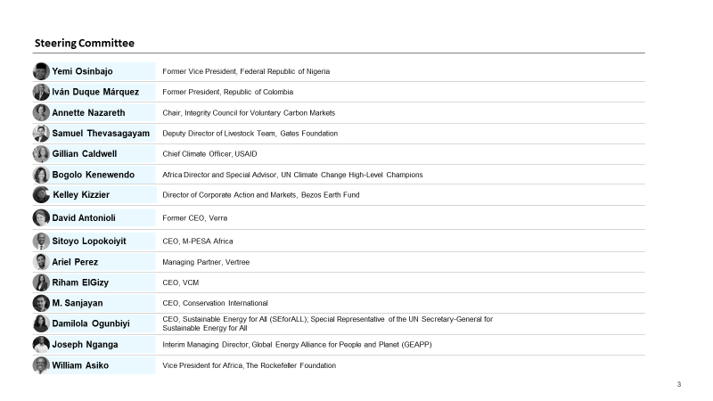

Forewords

Foreword from The Report Sponsors

As global climate action continues to evolve, it is becoming increasingly clear that African carbon markets can be a pivotal development pillar for Africa and unlock much-needed climate finance across the continent. Africa, with its rich natural diversity and complex socioeconomic dynamics, plays a key role in both the impacts and solutions of climate change. Carbon markets are more than an economic opportunity. They are a potential path to achieving the Paris Agreement’s climate goals and helping propel Africa on its path towards resilience and prosperity, in line with the African Union’s Agenda 2063.

Carbon markets can unlock new avenues for green growth. Carbon markets can help Africa tap into investments in renewable energy, sustainable agriculture, and biodiversity conservation, thus creating green jobs and combating energy poverty. What this drives is not just growth – it is sustainable growth with a socioenvironmental responsibility.

As Africa aims to scale its carbon markets, integrating advanced technologies and expertise is central, as it has the potential to catalyse innovation and environmental stewardship across the continent. It is pivotal to establish robust policies, regulations, and efficient market mechanisms, while ensuring broad-based participation to fully realise the potential of carbon markets. As we strive towards a sustainable, low-carbon Africa, the opportunities are significant, and the commitment from players across the continent is strong. This report serves as a roadmap for this effort, guiding our collective efforts to utilise carbon markets for climate mitigation, economic growth and to accelerate a just and equitable energy transition for Africa and beyond.

We acknowledge that the effectiveness and long-term viability of carbon markets in Africa depend fundamentally on their integrity and quality. As the continent grapples with deforestation, habitat loss, and biodiversity decline, it is crucial that carbon markets are designed and managed with stringent standards and transparent governance. These markets should also embody principles of equity and fair benefit distribution. It is essential that local and indigenous communities, who are often the guardians of these natural habitats, are not just participants but beneficiaries of the carbon markets.

As we look ahead to the mid-century timeline to achieve the Paris Agreement, it is important to highlight that carbon markets are not just effective tools for climate change mitigation and adaptation for Africa but also serve as catalysts for inclusive and sustainable development across the continent. We express our gratitude to everyone contributing to this journey and invite partners and stakeholders to join the ACMI to help shape Africa’s carbon market future. Together, we can create a legacy of positive impact for generations to come.

Damilola Ogunbiyi, CEO, SEforALL; Special Representative, the UN Secretary-General for SEforALL; Co-Chair, UN-Energy

Joseph Nganga, Interim Managing Director, GEAPP

William Asiko, Vice President of the Africa Regional Office, The Rockefeller Foundation

Foreword from ACMI’s CEO

Carbon markets, although in their infancy, are likely to become one of the key tools in the toolbox of financing climate action worldwide. In a world where ‘we must do everything, everywhere, all at once’, the advent of a transparent carbon market in Africa will enable both large and small players to develop projects of high integrity, with real climate action occurring on the ground. Africa is uniquely positioned to tackle climate change while improving livelihoods and protecting biodiversity. Its abundance of cost-effective clean energy allows for ‘prioritising energy-intense industries to trigger a virtuous circle of renewable energy deployment and economic activity [including] shifting the primary processing of Africa’s raw material exports to the continent’.

The Africa Carbon Markets Initiative (ACMI) was set up in response to this opportunity with one overriding objective: to work with partners to scale carbon markets in Africa that have integrity, equity, and transparency. In its first year, ACMI and its collaborators have made progress across the carbon market value chain, spanning supply and standards, intermediation and financing, demand, and cross-cutting topics. These achievements against ambitious goals are the product of ACMI’s proactive coordination with diverse actors and extensive stakeholder engagement focused on the areas with the greatest potential, drawing on ACMI’s support to drive practical impact. ACMI, together with partners, is working with governments to help them operationalise a conducive environment to, among other things, drive private-sector investment into carbon projects; working with different financing sector players to create de-risking solutions to ease the flow of capital to where it is most needed; and developing new project types and methodologies that apply global standards to the contextual realities on the continent, all with a view to unlocking new, untapped carbon credit potential across Africa.

ACMI upholds and supports global efforts to raise the bar on integrity in carbon markets. It articulates integrity across the value chain to unlock credible demand. This focus on integrity and quality cuts across our work on the operationalisation of Article 6, voluntary and compliance markets in line with national priorities and frameworks while addressing demands for integrity and transparency, backed by real-world data.

Africa is already on the path to driving green growth through renewable energies, sustainable agriculture, biodiversity conservation, and climate diplomacy. Small-scale sustainable projects in Africa function as key testing grounds for scaling such efforts globally in areas like blue carbon and AI-powered soil carbon projects. ‘Our continent has the fundamentals to spearhead a climate compatible pathway as a thriving, cost-competitive industrial hub with the capacity to support other regions in achieving their net zero ambitions’.

Building on years of work, ACMI is already well on its way in advocating for, advising, and assembling players across the African carbon markets value chain, activating economic as well as environmental impact. It is early days, but we are keen over the next two years to work with even more partners and stakeholders to make a carbon credit market for Africa a powerful force for good both for the continent and the world.

Paul Muthaura, CEO, ACMI

Executive summary: The Sponsor's Narrative on African Carbon Markets
A transformative force for good

2024 has highlighted major credibility issues in carbon markets. Several investigative publications have raised concerns that the true emissions reduction potential of many carbon credit projects has been overstated. In particular, projects based on avoiding deforestation (REDD+) were flagged for concern, such as Zimbabwe’s headline-making Kariba project. This issue is crucial, as REDD+ is the world’s largest single category of projects, comprising 28% of all credits issued since 2016. Similar concerns have been raised for projects that implement cleaner cookstoves. These issues have greatly impacted Africa. Cookstove projects, together with deforestation avoidance projects, comprise roughly 90% of Africa’s recent credit supply. When looking at buyers of carbon credits, there is intense scepticism that credits are used for greenwashing, an excuse to keep polluting. These issues have made carbon markets lose some credibility as a tool for addressing climate change or generating wider societal benefits. Existing concerns have been compounded by a lack of transparency about carbon credits and where their revenues go, as well as questions of carbon credit projects’ equity. Some people ask whether carbon credits, particularly large land-use projects, are causing Africans to lose their land to facilitate continued pollution by rich countries – driving concerns about a form of recolonisation in Africa. This is particularly important for projects that are used to help foreign countries meet their climate targets through Article 6 of the Paris Agreement, and many such initiatives have been flagged for particularly low transparency. They have been the main driver of the past year’s 22% reduction in global demand for carbon credits, leading to over-the-counter carbon credit prices dropping 30-50% from their peak to return to 2021 levels. All these concerns matter as they inform the new era of African carbon markets that are intent to uphold high-quality carbon credits and high-integrity carbon markets .

A lot is at stake, and failing to address these issues could prevent the market from unlocking substantial benefits for African people, economies, and livelihoods. Despite recent concerns, high-integrity, transparent, and equitable African carbon credits have continued to deliver benefits for broad sections of society (Exhibit 1). They support African income and jobs, food security, people’s health, climate resilience, and biodiversity, thus directly contributing to at least 10 of the United Nations’ 17 Sustainable Development Goals. With voluntary carbon credits valued at roughly $2 billion globally and potentially growing 5-50x by 2030, high-integrity carbon markets could provide significant benefits to African people and be a critical source of climate finance for the continent. But if these credibility issues prevail on the continent, markets will move forward without Africa. The immense opportunity for Africa could be missed entirely.

‘By developing a robust, transparent, and sustainable mechanism through which a carbon credits market can yield attractive income and development opportunities for communities at the frontlines in the fight against climate change, we will align incentives among polluting producers and sequestration enterprises to achieve net zero industrialisation and shared green prosperity.’ – H. E. William Ruto, President of Kenya.

Exhibit 1: Carbon markets deliver particularly valuable benefits for Africa across the Sustainable Development Goals
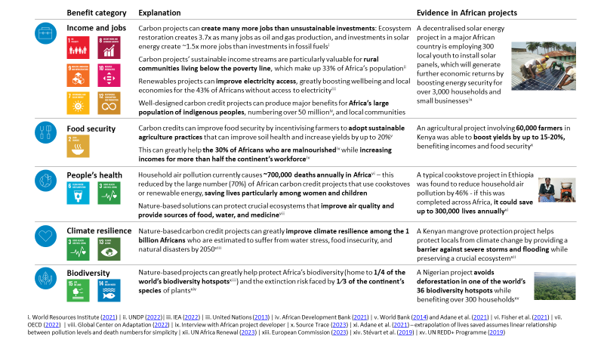

The Sponsors fully recognise these issues but have confidence in the ongoing, proactive efforts to solve them. Constructive scrutiny is a welcome check on maturing markets, helping actors rethink how they can best serve wider society. And many are already working diligently to address issues in carbon markets. On the supply side of voluntary markets, the Integrity Council for Voluntary Carbon Markets (ICVCM) recently launched its Core Carbon Principles (CCPs), setting out fundamental principles for carbon credit projects that help raise the integrity bar considerably. Additionally, standards bodies have published an updated integrity-boosting cookstove methodology and are due to release an updated REDD+ methodology that uses artificial intelligence and satellite data to boost integrity. On the demand side, new evidence shows that most businesses do not use credits for greenwashing but rather to decarbonise faster and help others do the same. A recent Sylvera report shows that, on average, companies that buy carbon credits reduce their emissions two times faster per year than companies that don’t. And the average business that buys carbon credits invests three times more in emissions reduction efforts within their value chain, helping other companies to decarbonise. In addition, markets have taken steps to prevent any remaining greenwashing by setting guidelines for using carbon credits and making credible claims. This has taken the form of the EU’s Green Claims Directive, the ISO’s Carbon Neutral Standard, the Voluntary Carbon Markets Integrity Initiative (VCMI) Claims Code of Practice, and the Science Based Targets Initiative’s (SBTi) Beyond Value Chain Mitigation reports. Further, several initiatives continue to enhance the transparency of carbon markets. New methodologies from the world’s largest standards providers undergo extensive public consultation. Additionally, most project methodologies require free, prior, and informed consent from local communities before carbon credit projects can start, as well as regular independent audits that engage community members. These mechanisms will increasingly help integrity concerns come to light, and the publication of ICVCM’s CCPs is a leading light for the wider carbon markets ecosystem. Indeed, at the time of writing, Standards representing 95% of the voluntary carbon market have met CCP-eligible status. ACMI is confident in this progress, and it is not alone. African leaders are increasingly backing carbon markets as an engine for green growth – made for Africa, by Africans. Ministers from Ghana, Malawi, Mozambique, and the Democratic Republic of Congo underlined this support at the Africa Climate Summit in September 2023. Support is also reflected in the push by leaders to develop sophisticated carbon market regulations in countries that include Kenya, Ghana, Mozambique, Senegal, and Zambia.

Over the period from ACMI’s launch to 2024, ACMI worked to help solve these issues by collaborating with carbon market actors to secure five headline achievements. In the past 12 months, we have built on existing market momentum and worked with partners to:
- Broaden our scope to integrate compliance carbon markets and mechanisms under Article 6 of the Paris Agreement, in addition to the initially targeted voluntary carbon markets.
- Engage seven countries to develop comprehensive carbon market frameworks through activation plans, collaborating with partners including USAID, SIDA, and Enabel while leveraging partner relationships to help create a market growth pathway that fosters high integrity and transparency.
- Aggregate intentions of USD 1 billion to invest into high-integrity African carbon credits by 2030, including USD 250 million of signalled investment intentions. This serves as an advocacy tool to signal significant offtake opportunities to project developers and investors, boosting both market confidence and demand.
- Compile the first-ever listing of African carbon credit projects, showcasing over 100 projects that aim to collectively offset over 90 MtCO₂e annually – providing transparency on Africa’s supply and benefits across projects.
- Develop a diesel/petrol generator phase-out methodology concept note, which has been approved by Gold Standard’s technical advisory committee, to channel valuable financing for clean energy.
These achievements were all made possible by ACMI working with partners and engaging with over 400 carbon market actors, many of whom are firmly behind high-integrity, high-equity, and at-scale African carbon markets.

The industry-wide outlook for the coming years outlined in this Report will further tackle the challenges needed to scale high-integrity African carbon markets and unlock benefits for the continent. As outlined in ACMI’s Roadmap Report 2022, ACMI used substantial market feedback to ensure that this organisation-specific strategy used ACMI’s unique position to help drive higher integrity and unlock benefits for Africa. This Report intends to build on this knowledge to foster collaboration for increased integrity, equity, and transparency while also championing African interests by advancing a positive narrative on carbon markets. Further, the Sponsors will work with partners to support governments, project developers, and communities through a combination of direct support and tools for effective regulation and high-integrity supply. Within this outlook, ACMI seeks to positioned itself as a central point of reference on the state of African carbon markets. ACMI seeks to convene market participants to build joint momentum around the path forward. We will complement these efforts by advocating for all forms of carbon credit demand (compliance, voluntary carbon markets, and international trading under Article 6), moving towards securing commitments and closing transactions.

To fully scale high-integrity African carbon markets and unlock their many benefits, all actors must come together with raised ambitions. ACMI’s 2022 Roadmap Report highlighted that Africa has the potential to scale its carbon credit market 19-fold by 2030, supporting up to $6 billion of revenue and 30 million jobs. Exhibit 1 shows that a high-integrity market of this size could be a major channel for green growth financing across the continent. However, realising this potential relies on all actors in African carbon markets playing a more prominent role. Governments must establish a clear and stable regulatory landscape conducive to scaling carbon markets. Suppliers must substantially scale the production of high-integrity credits that equitably share revenue with local communities. Buyers will need to set and act on credible net zero commitments. That means using credits alongside more ambitious efforts to decarbonise their operations while supporting a high-integrity supply pipeline by committing to long-term offtake. Each actor in the market has a role to play. Partner with ACMI and commit to playing yours.

‘The statistics are undeniable – Africa possesses immense potential for nature-based solutions, yet we have seen only a mere 2% of this potential transformed into carbon credits. This is a call to action, an opportunity that we must seize to mitigate the impacts of climate change and propel our continent toward a greener and more resilient future’ – Mohammed Amin Adam, former Deputy Minister for Energy, Ghana.

1. The past year for carbon markets

1.1. Key trends in global carbon markets

Globally, carbon markets have mobilised over $5 billion for carbon credits in the past five years and continue to deliver benefits across the Sustainable Development Goals. Carbon credits produce valuable benefits for many dimensions of society. In addition to the direct decarbonisation benefits outlined below, carbon credits create a substantial number of jobs and income for local communities while improving food security, health, climate resilience, and biodiversity (Exhibit 1.1.1). These benefits are particularly strong for well-designed projects, of the kind ACMI supports, that have high integrity and provide tangible, equitable outcomes for local communities.

Exhibit 1.1.1: Carbon markets continue to deliver benefits across the SDGs
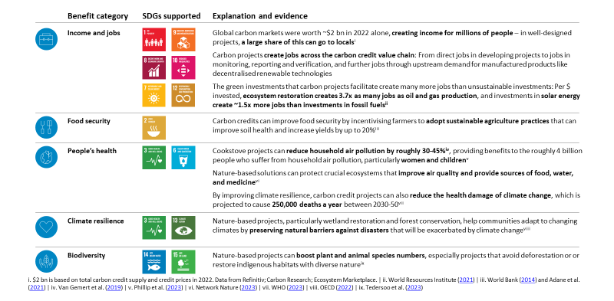

Carbon markets also continue to play a central role in reducing global emissions and are used by most businesses to go beyond ongoing efforts to decarbonise. Studies show that businesses that buy carbon credits tend to decarbonise faster, reducing their emissions annually by 6.2% compared to an average of 3.4% for companies that don’t. Additionally, the median business that buys carbon credits invests three times more in emission-reduction efforts within their value chain, helping other companies decarbonise. Beyond voluntary carbon markets, the prevalence of compliance carbon markets (Exhibit 1.1.2) is also a major driver of global emission-reduction efforts. Emissions trading systems and carbon taxes push companies to decarbonise through financial incentives, particularly among the emission-intensive power, energy, and heavy industry sectors. Moreover, carbon credits traded internationally per Article 6 of the Paris Agreement (Exhibit 1.1.2) can help ensure global decarbonisation efforts remain cost-effective. ACMI thus aims to support a range of carbon market systems that can each help decarbonisation and channel benefits to Africa.

Recent studies show that businesses that buy carbon credits decarbonise two times faster – on average, they reduce their emissions by 6.2% annually compared to 3.4% among companies that don’t buy credits.

Exhibit 1.1.2: There are key differences between voluntary carbon markets, compliance carbon markets, and internationally traded credits under Article 6 of the Paris Agreement
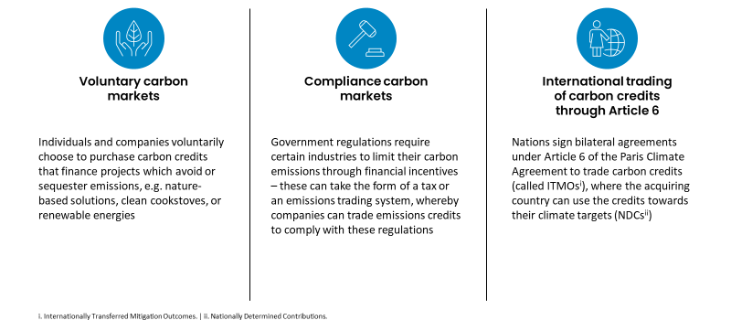

These benefits underpin a positive long-term outlook for carbon markets, which are projected to grow by five to 50 times by 2030 and support local communities and SDGs even more. Voluntary carbon markets are set to grow far beyond their current market size and are forecast to be valued in the tens of billions of dollars by 2030 (Exhibit 1.1.3). This projected growth establishes carbon markets as a meaningful vehicle for financing the green transition, representing approximately 1% to 2% of the annual investment needed for a 1.5°C-aligned future by 2030. Precise projections vary substantially based on different future pathways to decarbonisation. If climate action is delayed and companies only sparingly use carbon credits, then projections are for the value of carbon markets to reach roughly $10 billion to $20 billion. Conversely, if governments and companies rapidly raise climate ambitions, then market values could increase up to $100 billion by 2030 – with carbon credits playing a major role in filling the gap to reaching net zero by 2050. Beyond voluntary carbon markets, credits traded internationally under Article 6 of the Paris Agreement may also experience high growth over the coming decade. With such high growth projections across different carbon market types, major benefits will be unlocked for local communities and the SDGs if carbon markets retain a focus on high integrity, equity, and transparency.

Exhibit 1.1.3: Carbon markets are projected to grow substantially by 2030
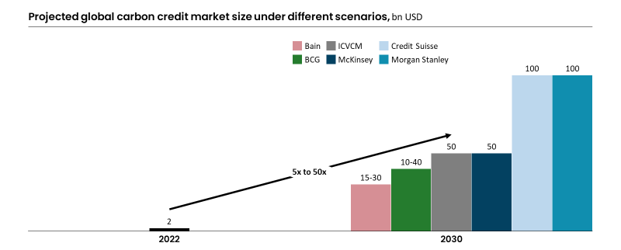

Despite a long-term positive outlook, the past year has seen a slight slowdown in carbon markets – globally there was a 22% reduction in demand in 2023, while supply has still increased by 9%, leading to prices that have largely returned to 2021 levels. Carbon credit demand (measured through voluntary credit retirements) has fallen mainly due to a handful of companies, such as Gucci, Nestle, and Delta, pausing their purchases of carbon credits based on recent concerns about credits’ integrity (see below). Demand has dropped most for forestry avoidance credits and renewables given heightened concerns about the integrity of these credit types. Carbon credit supply (measured through issuances) still increased by 9% relative to the previous year, but this growth was highly uneven. Growth was mainly driven by the release of 34 million credits for avoided deforestation projects through the ART TREES platform. In contrast, other credit types, such as afforestation projects and fossil fuel switching projects, saw drops in supply (Exhibit 1.1.4). These market dynamics have also affected carbon credit prices. Prices have largely returned to 2021 levels following a period of volatility in early 2023. Prices for over-the-counter credits (meaning credits traded directly between two parties), representing roughly 75% of credits, have decreased by 30% to 50% from their peaks in early 2022. Average prices for these credits are now around $3 for renewable energy carbon credits and up to $13 for credits from avoided deforestation (REDD+) and forest management projects. These prices also include intermediary fees, which are not well documented but have been estimated to be upwards of 15% of sales prices and can reach up to 300% in extreme cases. Average prices for credits traded on carbon market exchanges, which represent the minority of credits, have experienced greater volatility and have dropped substantially from their peaks at roughly $10 to $15 per tCO₂e to trading at $1 to $2 today.

Exhibit 1.1.4: Global carbon markets have seen a slowdown over the past year
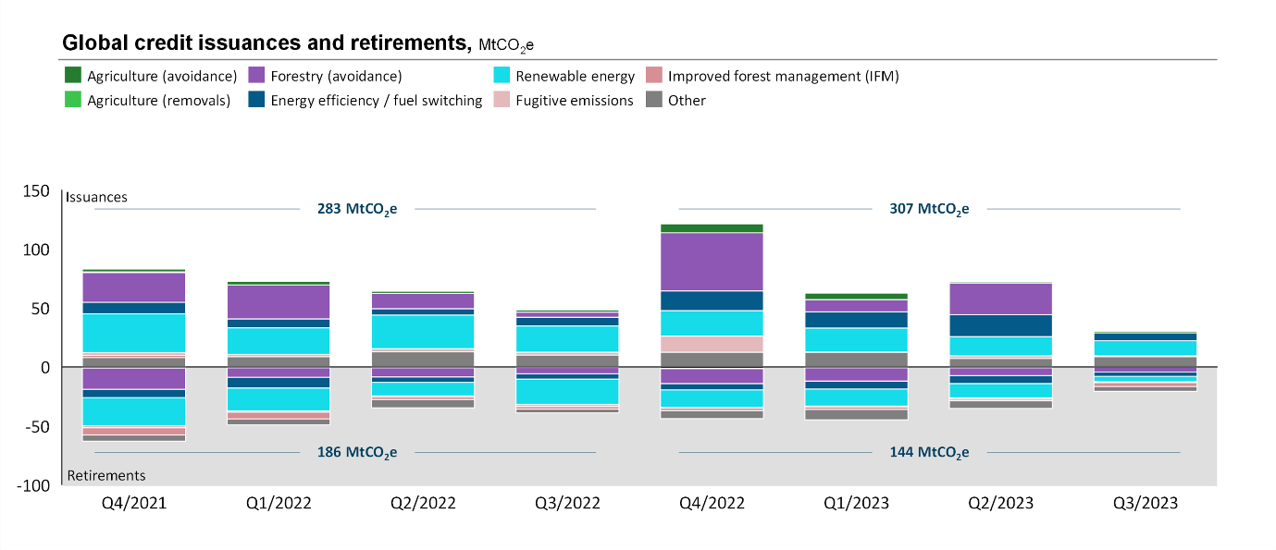

Two critical setbacks have driven the past year’s slowing market: (1) concerns about credit integrity and (2) adverse macroeconomic conditions. First, substantial concerns have been raised about the integrity of both credit supply and credit demand. On the supply side, several investigative publications have raised concerns that a substantial share of carbon credit projects for avoiding deforestation (REDD+) overstated their true emission-reduction potential. REDD+ credits provide finance to landowners to protect land from deforestation. Investigative studies suggested that the protected land would not have been deforested in many cases, even without carbon credit financing, meaning that carbon projects were attributed with greater emission-reduction credits than appropriate. This is crucial, as REDD+ is the world’s largest single category of projects, comprising 28% of all credits issued since 2016. Concerns have also been raised about the integrity of other project types, such as cookstove projects, and scrutiny has led Verra to recently deactivate its methodology for avoidance credits from rice farming. Scrutiny has also been mounting regarding the transparency of carbon credits and where their revenues go, as well as questions of carbon credit projects’ equity. Some people ask whether carbon credits, particularly large land-use projects, are causing Africans to lose their land to facilitate continued pollution by rich countries – driving concerns about a form of recolonisation in Africa. On the demand side, intense debate has emerged around the role of carbon credits in greenwashing, with frequent claims made that businesses use credits as an excuse to keep polluting. Additionally, as the international trading of carbon credits under Article 6 continues to gain momentum, these projects have been flagged for particularly low transparency. ACMI welcomes public scrutiny of the integrity of carbon credits and firmly believes constructive scrutiny is a valuable check on maturing markets. But it remains necessary to highlight that well-designed carbon credits continue to bring valuable benefits and accelerate decarbonisation. New methodologies and standards frameworks will help carbon credits unlock these benefits, as outlined below. Second, macroeconomic growth has slowed globally, with markets under pressure due to recent geopolitical tensions. Declines in growth have been sharpest in high-income countries, thereby squeezing corporate budgets in the countries that demand the bulk of carbon credits.

Exhibit 1.1.5: The past year’s slowing market has been driven by two critical setbacks, but four significant market opportunities will help carbon markets unlock five- to 50-fold growth over the next decade
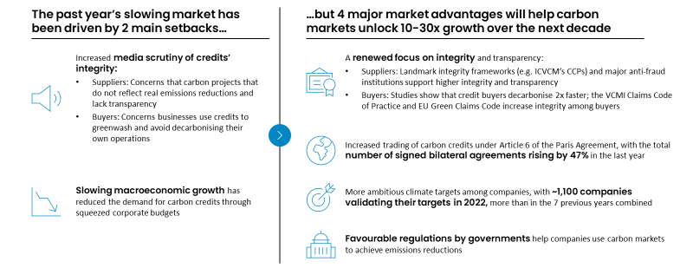

However, four market opportunities mean that global carbon markets can still unlock five- to 50-fold growth over the next decade: (1) a greater focus on integrity, (2) favourable government regulation, (3) increased trading under Article 6, and (4) increasingly ambitious climate action among businesses. First, carbon markets have responded to recent scrutiny by establishing the foundations for a more sophisticated, transparent, and high-integrity market. On the supply side, ICVCM, which sets global benchmarks for carbon credits, launched its final CCPs in March 2023. These set fundamental principles for the development of high-integrity carbon credits. Additionally, Verra has published an updated integrity-boosting cookstove methodology and REDD+ methodology. Meanwhile, the US Commodity Futures Trading Commission established an Environmental Fraud Task Force in June 2023, addressing potential fraud in carbon credits’ reported benefits and further increasing transparency. On the demand side, the European Union’s Green Claims Directive supports better governance for corporate green claims by proposing criteria for businesses to credibly make claims about the environmental merits of their products and services. The VCMI Claims Code of Practice, ISO’s Carbon Neutral Standard, and SBTi’s ‘Beyond Value Chain Mitigation’ publications all further boost buyer integrity by providing guidance on how to use credits as part of a company’s credible emission-reduction claims and strategies.

Second, governments are establishing favourable regulations that can fuel carbon credit demand by helping businesses use carbon credits to achieve emission reductions. Singapore, for example, has designed regulations allowing companies to use high-integrity carbon credits from abroad to compensate up to 5% of their payments to Singapore’s carbon tax. Similar regulations have been issued in Colombia, but they currently only allow domestic carbon credit purchases. This kind of regulatory effort can further boost demand for carbon credits and send a valuable market signal of trust in credits.

Third, the trading of carbon credits between countries under Article 6.2 of the Paris Agreement is growing. Article 6.2 allows for emission reductions in one country to be transferred to another and applied against its decarbonisation targets. Increasingly, countries are signing bilateral agreements of this sort (Exhibit 1.1.6), facilitating better collaboration as buyers reduce global emissions cost-efficiently while channelling investment to carbon credit suppliers. 21 agreements have been signed in the past year, increasing the total agreements to 64, a rise of 47%.

Exhibit 1.1.6: Increasingly, countries are trading carbon credits under Article 6.2 of the Paris Agreement
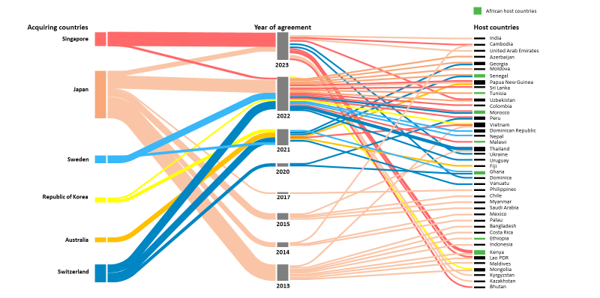

Fourth, increasingly ambitious corporate climate targets will likely fuel demand for carbon credits. Thousands of companies have now made commitments to net zero, with over 2,000 companies’ targets being validated by SBTi, the major measurement and validation body for climate targets. In 2022 alone, around 1,100 companies validated their targets with SBTi, which is more than in the seven previous years combined. This increased ambition is likely to translate into higher carbon credit demand, particularly as businesses seek to offset any residual emissions that they struggle to decarbonise. Reflecting these trends, over 1,000 new businesses have entered voluntary carbon markets in 2023 alone – if these companies were to offset just 1% of their emissions, then carbon credit demand would rise fourfold. Looking to the future, businesses have also signalled confidence in voluntary carbon markets’ long-term growth, with a growing number of forward contracts issued for businesses in the past year.

‘[Carbon markets are] the type of innovation that’s needed to fully address climate change. Without this, we don't make it. The only way we get there is to deploy those trillions of dollars.’ – John Kerry, United States Special Presidential Envoy for Climate

These market opportunities have the potential to cascade to African carbon markets, driving benefits across the continent, as detailed in Chapter 1.2.

1.2. Key trends in African carbon markets

While benefits continue to be high globally, this is particularly true in Africa, where carbon credits are delivering significant impacts for communities and providing numerous green growth opportunities. Given Africa’s unique social, economic, and environmental context, many of the benefits stemming from carbon markets are particularly high (Exhibit 1.2.1). Beyond these benefits, carbon markets also provide a significant opportunity for Africa to unlock green growth. More specifically, carbon credits present a scalable option for effective climate finance in Africa that will materially aid decarbonisation on the continent. They also mitigate the continent’s risk of ‘carbon lock-in,’ whereby high-emissions energy infrastructure built today causes society to remain dependent on fossil fuels in the future.

Exhibit 1.2.1: Carbon markets continue to deliver particularly valuable benefits for Africa
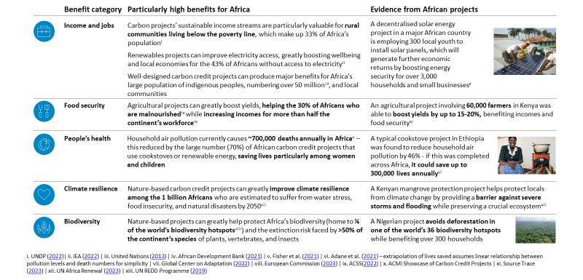

‘Carbon markets can be used to create resilience, vitality – we ought to be using carbon markets to improve health and reduce pollution.’ – Andrew Steer, President and CEO of Bezos Earth Fund

Contrary to global trends, African carbon markets have still experienced some growth, with an 11% increase in demand and only a 1% decrease in supply over the past 12 months. Overall, demand for carbon credits (measured through retirements) in the past 12 months was 11% higher than in the previous year. There was particularly high growth in energy efficiency and fuel switching projects (for example, cookstove projects), with retirements increasing by 56% to 10.8 million credits total over the past 12 months. Projects seeking to avoid emissions from agriculture (for example, agroforestry, no-till farming) also grew substantially compared to last year, increasing by about 25% to almost 500,000 credits. However, there has been a substantial drop in demand for forestry avoidance projects. This reflects heightened public scrutiny of these credits’ integrity, as noted in Chapter 1.1. Supply for carbon credits (measured through issuances) was roughly 1% lower than in the previous year. Parallel to demand, issuances of avoided forestry projects declined substantially, but there was strong growth in issuances of energy efficiency and fuel switching projects. In addition to supply and demand, credit prices are crucial for understanding the value of Africa’s voluntary carbon markets. Africa produces more credits than the global average from categories that command high prices, but anecdotal evidence indicates that, for the same project type, African carbon credits may command lower prices than the global average.

Exhibit 1.2.2: Contrary to global trends, African carbon markets have still grown slightly over the past 12 months
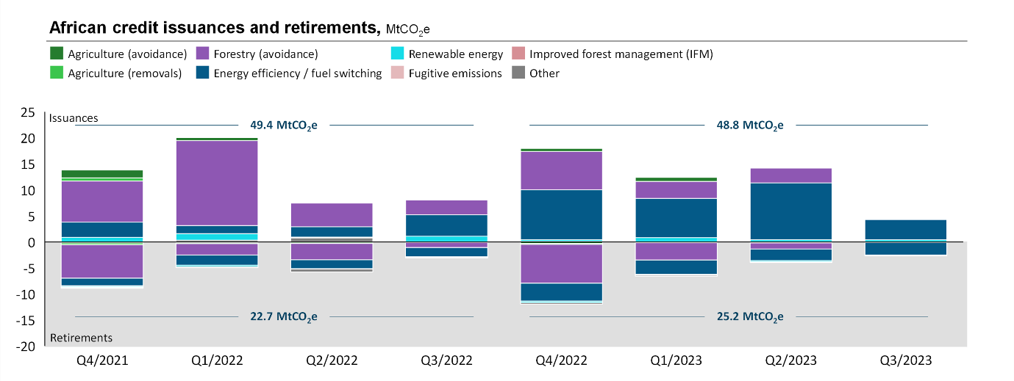

Despite demand growth, African carbon markets still comprise only about 16% of the global credits market and face challenges that can hinder future growth potential. Africa’s carbon markets issued approximately 50 MtCO₂e of credits and retired an estimated 25 MtCO₂e in the past year, far below the markets’ technical potential and stated ambitions. Africa’s total technical potential for voluntary carbon markets is 2,400 MtCO₂e by 2030, and ACMI’s ambition is for 300 MtCO₂e of African credits to be retired annually by 2030. Both global and Africa-specific challenges hinder this substantial potential for growth. Global integrity challenges have particularly strong implications for Africa. These concerns are particularly important in Africa, where REDD+ and cookstove projects comprise almost 90% of the past two years’ credit supply. Both REDD+ and cookstove carbon projects have seen intense global scrutiny over the past year, and together these comprise almost 90% of African credit supply in the past two years. Numerous specific African projects have come under the spotlight as part of the past year’s intensified scrutiny of credits’ integrity. Recent reports indicate that the Kariba carbon megaproject in Zimbabwe, for example, has claimed five to 30 times more emission reductions than its actual level. Beyond these global issues, Africa also faces unique challenges spanning the carbon market value chain. These include a high investment risk, high upfront costs for project development, and regulatory complexity (see Chapter 2.4 for a complete overview). Some recent trends have sharpened these challenges, such as regulatory decisions that have increased political risk. For example, Zimbabwe’s recent regulatory developments (Exhibit 1.2.3) intensified investor speculation that other countries could follow suit and highlighted potential political risk.

To tap into its full carbon market potential, Africa must seize the momentum behind four global market opportunities with specific relevance for the continent: (1) a greater focus on integrity, (2) favourable government regulation, (3) increased trading under Article 6, and (4) increasingly ambitious climate action among businesses. First, the world’s growing focus on integrity is particularly important for Africa. Verra’s work to update its methodologies for both cookstove projects and REDD+ projects is particularly important for high-integrity African credits, as these two credit types comprise almost 90% of African credit supply in the past two years. Working to adopt these new standards will greatly boost African projects’ integrity and benefits for all. Additionally, ICVCM has elevated its focus on involving indigenous peoples and local communities (IP&LCs), which will allow African carbon credit projects to improve transparency, increasing investor confidence and boosting demand. Second, African countries’ actions are a key part of the momentum behind favourable government regulations, and continuing this momentum while raising ambition is crucial. Several countries have made progress on developing favourable regulations – these include Kenya, Ghana, Mozambique, South Africa, Egypt, Senegal, and Zambia (Exhibit 1.2.3). Third, African countries are actively seizing the momentum behind exporting carbon credits under Article 6 (see Exhibit 1.1.2). One-third of all country-to-country agreements signed in the past year have involved African countries. Ghana has taken a leading role in these initiatives, while Senegal and Zambia have also made substantial progress (Exhibit 1.2.3). Continuing this momentum is key for boosting credit demand. Fourth, many businesses across the globe are increasing their climate ambition, with more businesses entering voluntary carbon markets in 2022 than ever before. This offers a major opportunity for African carbon credit projects to attract increased demand, particularly if businesses have confidence in African credits and can easily access the rich range of African projects.

Exhibit 1.2.3: Many African governments have developed new carbon market regulations in the past year
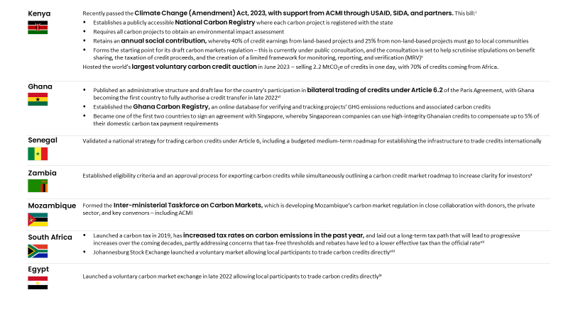
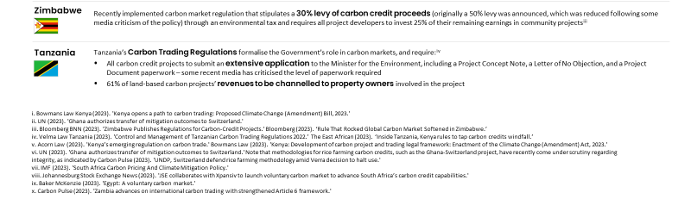

Harnessing these market opportunities can benefit the entire value chain of African carbon market players and build on the significant growth momentum of the past year. As shown in Exhibit 1.2.4, the carbon credit landscape in Africa has evolved across each stage of the value chain. Compared to 2022, major project developers (for example, Wildlife Works) have increased their supply on the continent. The use of registries has also diversified, with Gold Standard certifying 31% of African projects, up from 19% last year and mainly displacing Verra for certification. Among intermediaries, AirImpact and Climate Impact X have increased their involvement across Africa. The top buyers of African credits have also shifted to include more oil and gas companies (for example, Eni and Shell) and technology companies (for example, Apple). In contrast, last year’s largest buyers included airlines (for example, Delta) and consumer retail (for example, Gucci).

Exhibit 1.2.4: An updated view of the main players across the African carbon markets value chain
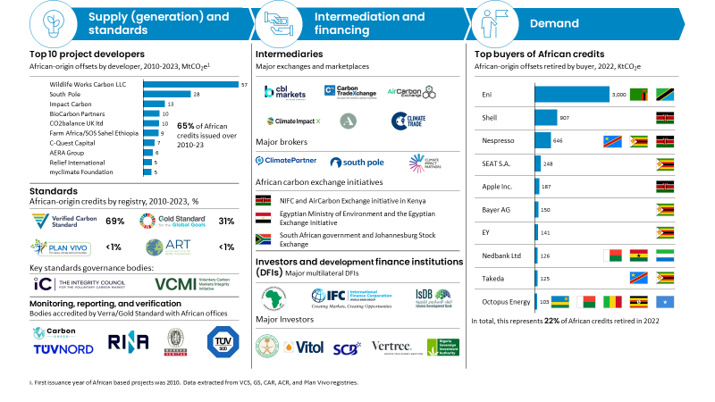

Unlocking Africa’s potential will see the continent become a major player in carbon markets by 2030, delivering significant benefits along the way and propelling its role in global green growth. As indicated in the 2022 Roadmap Report, Africa can feasibly retire up to 300 MtCO₂e of credits annually by 2030. This can mobilise up to $6 billion of capital while supporting up to 30 million jobs. It would position Africa as a major player in global carbon markets and further benefit Africa’s population. Africa is already on the path to driving green growth through renewable energies, sustainable agriculture, biodiversity conservation, and climate diplomacy. Africa has issued almost 2 MtCO₂e of credits for renewable energy projects in the past year and the continent is increasingly moving towards decentralised renewable technologies, where it is becoming an essential carbon market player. Small-scale sustainable agriculture projects in Africa function as key testing grounds for scaling such efforts globally. Recent innovations include the world’s first community-based blue carbon initiative to successfully trade carbon credits produced from mangrove conservation and an AI-powered soil carbon project that supports smallholder farmers in East Africa. As for biodiversity, Africa is home to a quarter of the world’s hot spots, and recent projects for biodiversity crediting, such as a UK-funded pilot in Uganda, will help cement its central role in global biodiversity conservation. Finally, Africa has more proactively propelled itself into the spotlight of global climate diplomacy, partly leveraging growing credibility from its carbon market progress. This year, the world’s first Africa Climate Summit resulted in the Nairobi Declaration on Climate Change, which makes a strong call for more climate financing to be directed to the Global South, with carbon markets explicitly cited as a core part of this effort.

2. From launch to the present for ACMI

2.1. ACMI’s standalone achievements and action programmes

Over the past year, ACMI has generated significant momentum to help scale high-integrity carbon markets across Africa. ACMI aimed to drive action across the carbon market value chain through close collaboration with many of its partners and carbon market actors since its launch at COP 27 in 2022. In pursuing impact, ACMI aimed to seize on existing momentum in the market and work collaboratively as it grows as an organisation. ACMI aimed to position itself as the voice of carbon markets in Africa, generating huge interest in African carbon markets both across the continent and on the global stage.

ACMI’s momentum is particularly apparent in its five headline achievements over the past year, which are the product of close collaboration across the carbon market ecosystem. ACMI has made five headline achievements in the past year (Exhibit 2.1.1). Across these achievements, ACMI has worked closely with its partners and with the wider carbon market value chain. Achievements were made by focusing on where there was existing momentum in the market for impact, which helped ACMI generate high impact. This approach also led to many more achievements which are outlined in Chapter 2.2. Across the over 400 carbon market actors and more than 20 countries that ACMI has engaged with, many stand firmly with ACMI in its vision for high-integrity, high-equity, and at-scale African carbon markets.

‘Let us imagine a pathway for different financial structures that can deliver on Africa’s goals. Let us commit to invest in viable solutions presented by renewable energy, green industrialisation, climate smart agriculture and nature conservation.’ – H. E. William Ruto, President of Kenya, at Africa Climate Summit 2023.

Exhibit 2.1.1: By engaging with over 20 countries and more than 400 players across Africa, ACMI and its collaborators have made five headline achievements over the past year
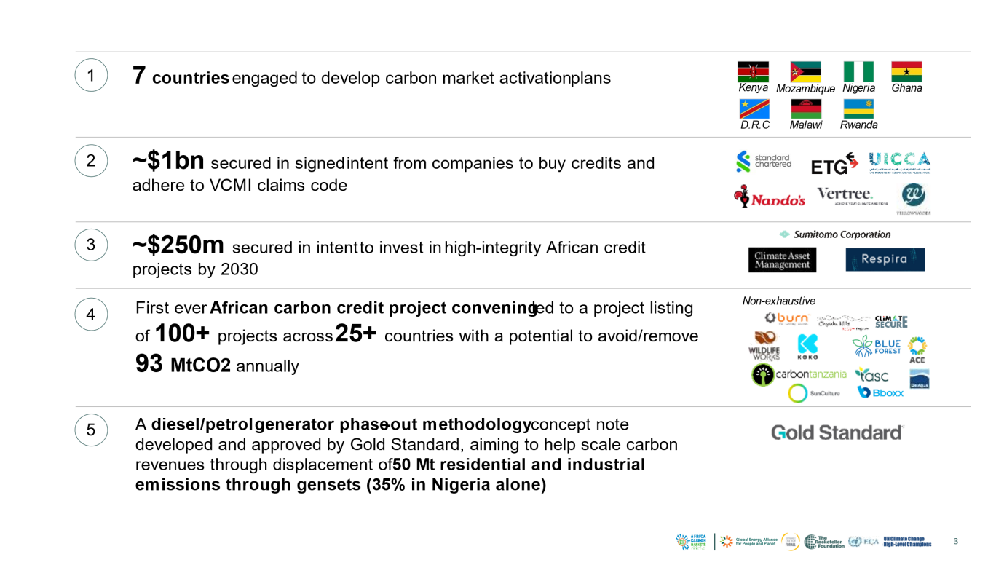

ACMI built this momentum hand in hand with key collaborators by prioritising eight of the 13 action programmes outlined in its 2022 Roadmap Report. Initially, 13 action programmes were identified as necessary to scale African carbon markets at a holistic ecosystem level (Exhibit 2.1.2). However, based on extensive stakeholder feedback, ACMI prioritised collaborating on those programmes where it saw the greatest potential for ACMI’s support to drive practical impact. The deprioritised action programmes were either folded into other action programmes (as in the case of Action Programmes 3, 9, and 12) or alternative players in the carbon markets ecosystem were deemed to be better placed to make progress (as in the case of Action Programmes 8 and 11).

Exhibit 2.1.2: ACMI’s headline achievements were made by working collaboratively on eight of the 13 action programmes that it outlined in the 2022 Roadmap Report
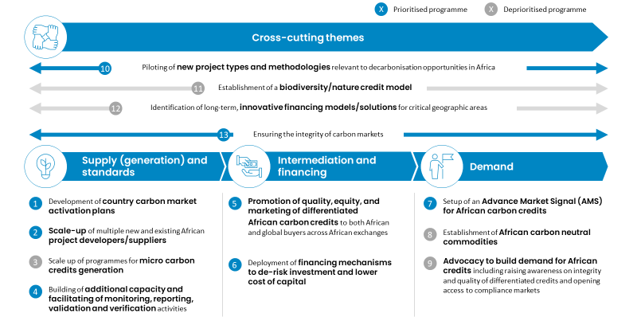

Details on the progress made for each priority action programme are presented in Chapter 2.2.

2.2. ACMI’s progress in tackling key barriers to carbon markets

ACMI and its collaborators have made progress on priority action programmes across the value chain, spanning supply and standards, intermediation and financing, demand, and cross-cutting topics. Progress on each action programme is outlined below.

‘Through ACMI, African countries are positioning themselves to meet the demands of the environment and development challenges at the same time … but this market must grow in order to work effectively.’ – John Kerry, United States Special Presidential Envoy for Climate

Supply and standards

Action Programme 1: Development of country carbon market activation plans

Context: Developing effective carbon market regulations is an important mechanism to support Africa on its path to net zero and has the potential to greatly increase the flow of climate financing and boost sustainable development. African governments are increasingly seeking to create environments that provide clarity to carbon credit buyers and investors while helping project developers scale. To achieve this, there is a growing need to better define regulatory frameworks for regional carbon markets. The importance of a robust regulatory framework was seen in recent major policy decisions across Africa (see Exhibit 1.2.3) that attracted strong responses from private-sector actors in carbon markets. Developing a plan for carbon market regulation is thus a useful starting point for any country seeking to build a carbon ecosystem. A holistic plan may include the development of relevant regulations and policies, approaches for stimulating private-sector engagement and investment, setting clear national carbon market ambitions, and the integration of carbon markets into broader climate plans. Carbon market activation plans (CMAPs) provide a single, comprehensive package to execute all these steps effectively. Given their importance, ACMI has collaborated with the United States Agency for International Development (USAID) and Sida over the past year to develop a CMAP blueprint that will be deployed in countries across Africa.

Progress: ACMI has collaborated with major governments to make substantial progress towards its goal of launching three CMAPs across the continent, with two CMAPs in development and four more countries in advanced discussions. ACMI has supported Kenya and Mozambique to get CMAPs underway. In Kenya, with support from USAID and Sida, ACMI supported the government of Kenya by providing a comprehensive set of options and considerations across the various topics that were being considered in developing the legislation and regulations to support carbon market growth. Significant efforts were made to build capacity across these topics and an understanding of the implications of different decisions, as well as distil the feedback from the private sector and other relevant stakeholders. In Mozambique, ACMI worked closely with the Ministry of Finance to advise on the establishment of a carbon market task force, and has been working with the task force to build a comprehensive view of what is required to develop a CMAP, including a detailed work plan and budget. ACMI also helped convene potential funders in Mozambique and bring them to the task force to understand the government’s request for support in developing carbon market regulations and a broader CMAP. Thanks to support from Sida, Enabel and a variety of other partners, the task force commenced the development of a CMAP at the end of 2023, with the help of a technical delivery partner. ACMI is also working with four other countries to highlight the technical and administrative requirements for CMAPs and convene donors so that they can launch their own CMAPs shortly (Exhibit 2.2.1). Additionally, ACMI has engaged with multiple countries to underline the opportunities inherent in effective carbon market regulations. It has also convened country and donor meetings to disseminate technical information that outlines considerations when embarking on the CMAP journey. Together, all these efforts help governments establish the regulations required to facilitate a thriving carbon markets ecosystem, which is foundational for unlocking carbon credits’ full benefits.

Exhibit 2.2.1: ACMI has supported numerous CMAPs across the continent
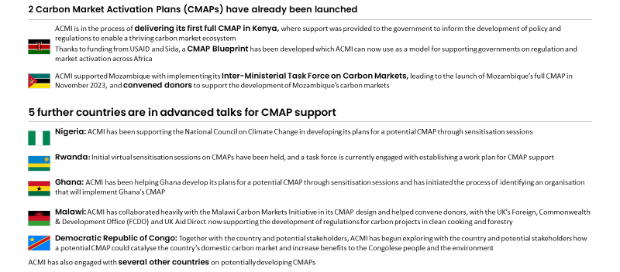

Action Programme 2: Scale-up of multiple new and existing African project developers/suppliers

Context: African project developers still need to achieve sufficient scale to ensure rapid growth in the supply of high-quality carbon credits. However, they represent a crucial change agent if Africa’s carbon markets are to scale 19-fold to produce more than 300 MtCO₂e carbon credits by 2030. The current project developer landscape in Africa consists of 150 to 200 companies, with the vast majority being small start-ups and roughly only 15 larger-scale developers (more than 3 MtCO₂ per year). Of all the project developers, 65% operate only one project, while 80% operate in only one country. If Africa’s carbon credit supply is to grow, it is paramount that developers receive assistance to scale their operations substantially.

Progress: ACMI aimed to help scale project developers by tackling the main challenges they face. ACMI consulted over 40 African project developers to identify key areas to address in assisting them to scale. These included the developer’s limited ability to identify the most relevant project methodologies or estimate carbon revenue potential, as well as a need for more support in navigating validation and verification pathway complexities.

In the past year, ACMI designed a Carbon Hub, and in collaboration with FSD Africa, the first phase of deep implementation is now underway. The Hub is a central repository of carbon markets information, from 101 knowledge all the way through to sector specific content. ACMI has designed a high-level outline of the design and gauged the requirements to build a fully operational Hub. Building on this, FSD Africa has partnered with ACMI to kickstart the first phase of development. Overall, the programme will be key for helping developers grow and launch more high-integrity projects. We welcome a broader spectrum of partners to support the operationalization of the Carbon Hub as centralized reference point thereby easing visibility and access to information while fully recognizing and acknowledging the IP rights in all such information.

Action Programme 4: Building of additional capacity and facilitation of monitoring, reporting, validation (MRV) and verification activities of carbon credit generating projects in Africa

Context: Scaling third-party verification of carbon crediting projects is a cornerstone for Africa’s growing high-integrity carbon market. Across the continent, there are very few validation and verification bodies (VVBs). Of the roughly 40 VVBs listed as accredited by Verra and Gold Standard, only 6 have offices on the continent. This bottleneck can be resolved by scaling verification capacity on the continent through training, sharing analysis on business opportunities, and supporting the creation of new local VVBs. Additionally, reviewing standards and leveraging new technology can speed up the carbon credit monitoring, reporting, and verification (MRV) process. This would free up capacity for more verifications across the continent.

Progress: In response, ACMI designed an auditor training programme and disseminated analysis on the VVB opportunity to attract new investment in the space. To reduce the costs of training new auditors in African VVBs, ACMI developed a training programme to reduce the job readiness period for new auditors from 18 months to roughly six months. The training programme will be deployed in partnership with relevant stakeholders. ACMI also encouraged auditing firms active in the region and smaller African companies in parallel industries (for example, testing inspection and verification) to move into carbon credit auditing. For this purpose, ACMI conducted an analysis of VVBs, including estimates of future market sizes, and pitched the business opportunity for VVB services to key auditors based out of Africa. As a result, multiple auditors with value pools in Africa are now considering moving into this space.

Intermediation and financing
Action Programme 5: Promotion of quality, equity, and marketing of differentiated African carbon credits to both African and global buyers across African exchanges

Context: Project developers have a significant opportunity to attract demand and showcase their unique products to buyers through the intermediation market. This is essential for attracting the level of demand that will see Africa scale carbon markets to mobilise up to $6 billion annually by 2030. However, key challenges in Africa’s intermediation market currently make carbon credit sales substantially less profitable for project developers and ultimately reduce the economic benefits flowing to local communities. The first challenge is that project developers rely heavily on the services of brokers and traders and lack direct connections to buyers. Second, project developers face high intermediation costs, with stakeholders reporting a 10% to 70% margin for brokers and traders. Third, project developers have little transparency on prices and margins charged by different intermediaries, hindering them from cost-effectively navigating the intermediation market.

Progress: ACMI has aimed to address these challenges by convening African auction houses, marketplaces and exchanges to harmonise trading principles, particularly around integrity principles, pricing, and quality. Over the past year, ACMI has developed partnerships with intermediaries to bring transparency to carbon credit markets, aiming to boost integrity and facilitate connections to key stakeholders. This sets the foundation for helping project developers navigate Africa’s landscape of brokers and traders, which can ultimately help developers and local communities retain more of the revenue from carbon credit projects.
Action Programme 6: Deployment of financing mechanisms to de-risk investment and lower project developers' capital cost

Context: Currently, African carbon markets face major financial barriers that prevent them from accessing necessary capital. These barriers stem from three key challenges related to investment risk. First, African project developers lack access to the early-stage, high-risk capital required to take a project through the feasibility phase. Second, there is a lack of access to affordable financing options for developing and scaling projects across the continent. Third, investors lack hedging mechanisms against various risks, including political and buyer risks.

‘There is a risk that VCMs [voluntary carbon markets] in Africa may fail if there is no trust from investors.’ – Tariye Gbadegesin, CEO of Climate Investment Funds and former Co-Chair of VCMI.

Financial players can address these challenges by developing risk-mitigating mechanisms adapted to African carbon markets’ needs. Developing these mechanisms is foundational to unlocking carbon markets’ potential to benefit African communities, economies, and the environment.

Progress: Over the past year, ACMI has made substantial progress in pushing the thinking on how to address these core challenges, bringing together players to develop concepts for five innovative mechanisms. Developed by ACMI in collaboration with key intermediation and financing stakeholders, these mechanisms (Exhibit 2.2.2) address the significant barriers project developers and investors face. ACMI convened major financial players from the private sector, public sector, and multilateral institutions (see Chapter 2.3) to provide input on potential designs. ACMI is in discussions with major multilateral financial institutions on the design and possible implementation of three of the five mechanisms.

Exhibit 2.2.2: ACMI has convened key players to develop concepts for five innovative financial mechanisms
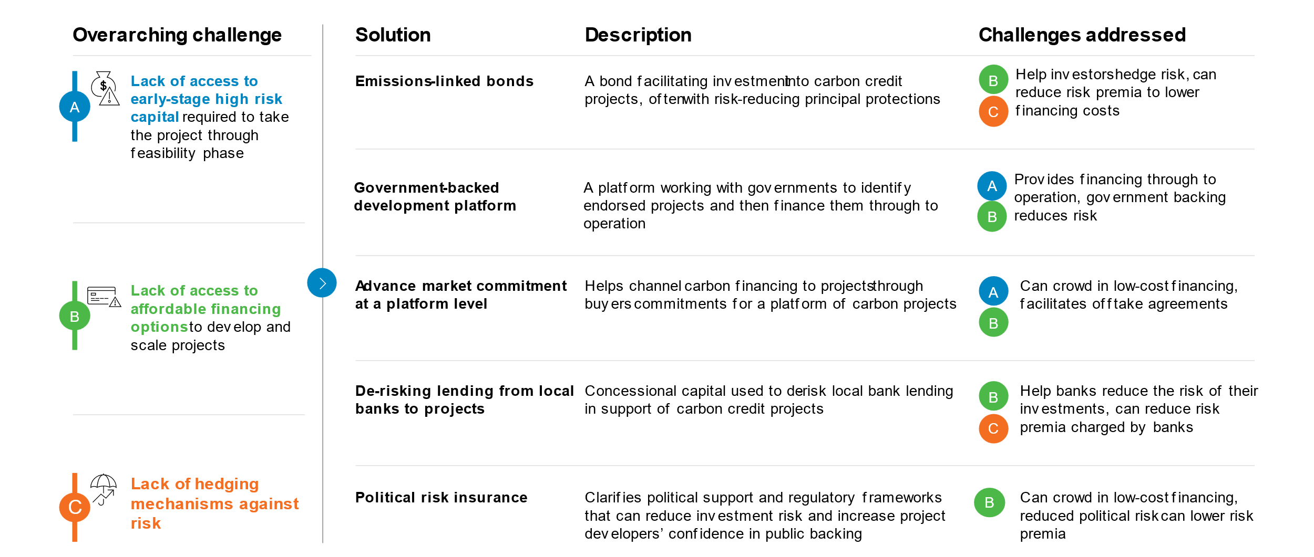

Additionally, ACMI has secured letters of intent from investors to invest $250 million by 2030 in the development of high-integrity carbon credit projects in Africa. Letters of intent are highly valuable for carbon markets, as they can crowd-in financing by improving risk perception among investors while also sending a strong demand signal to project developers. Over the past year, ACMI has worked with investors, including Climate Asset Management and Respira International, to secure letters of intent totalling $250 million, which reflects buyers’ intent to invest in carbon projects. Together, letters of intent and de-risking mechanisms will help unlock the capital needed to help grow the supply of high-integrity African projects.

Demand
Action Programme 7: Setup of an Advance Market Signal for African carbon credits

Context: Advance market signals support growth in carbon markets by catalysing demand and helping project developers scale their supply. Advance market signals are public statements signalling intent to purchase credits for a defined dollar value over a specified period. They have great potential to accelerate carbon credit demand by unlocking financing for project developers, ensuring sufficient income for credits, facilitating connections between buyers and suppliers, and securing a supply of high-integrity credits. This is especially valuable, as many buyers do not have an accessible view of the full range of supply of African credits.

Progress: Under the ACMI’s advance market signals for end buyers of carbon credits, significant progress has been made to convene buyers, build a supply tool and facilitate transactions. $650 million in signals have been confirmed from Standard Chartered, Vertree, Nando’s, ETG, and the UAE Carbon Alliance for the purchase of African carbon credits. This reflects project developers’ confidence in the demand for carbon credit purchases.

To provide an accessible view of high-integrity supply, particularly for advance market signal signatories, ACMI has worked with roughly 65 project developers to create the first edition of the African Carbon Credit Showcase. The showcase is a compilation of over 100 African carbon projects that abide by ACMI’s integrity principles (see Action Programme 13). ACMI used its convening power to run an open call for project developers to submit high-integrity projects. It aims to demonstrate the breadth and depth of the African carbon credit supply, giving confidence to buyers around the quality and quantity of supply available (Exhibit 2.2.3). The premier showcase document is only a sample of the supply available in Africa and lists projects with an annual offset capacity of reportedly 93 MtCO₂e. The showcase document contains broad coverage of the African continent, including more than 20 countries and over 65 project developers. Major sectors represented are renewable projects (27%), household devices (16%), forestry (14%), and energy efficiency (13%). The showcase is focused on projects that will generate emission reductions in the near future, with 76% of the projects generating their first reductions between 2020 and 2024. The projects featured also exhibit a wide range of benefits, indicative of the diverse benefits that African carbon credits generate (Chapter 1.2).

Exhibit 2.2.3: ACMI’s African Carbon Credit Showcase presents over 100 high-integrity carbon projects that produce substantial benefits and help attract carbon credit demand to the continent
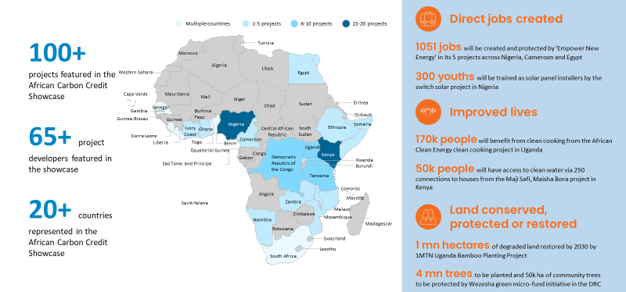

Cross-cutting
Action Programme 10: Piloting of new project types and methodologies relevant to decarbonisation opportunities in Africa

Context: Carbon project methodologies will help developers increase their supply of projects supporting Africa’s unique mitigation opportunities. So far, carbon credit projects in Africa have been mainly focused on agriculture (around 5%), forestry and land use (about 45%), and cookstoves and energy (roughly 50%). There are either no current methodologies for certain Africa-specific decarbonisation opportunities (for example, phasing out fossil fuel–based generator sets, see below) or existing methodologies do not account for the local context. Many methodologies require multiple years of data to establish emissions baselines, which may not be available in African countries. At the same time, others are ill-suited for the agricultural settings prevalent across the continent. Overcoming these constraints could help Africa generate approximately 400 MtCO₂e of carbon credits annually in 2030 from new and nascent methodologies, or 15% of the continent’s total technical potential of 2.4 GtCO₂e, based on ACMI’s 2022 Roadmap Report. Specifically, creating and testing methodologies for displacing fossil fuel–based generators and livestock decarbonisation could unlock 170 MtCO₂e.

Progress: ACMI has worked with project developers and advisors to unlock more high-integrity credits by designing a carbon project methodology concept note for phasing out fossil fuel–based generator sets. The new methodology designed by ACMI, in consultation with stakeholders, can help developers generate credits that support the phase-out of fossil fuels. This can unlock substantial decarbonisation benefits for local communities and entire nations, as currently one of every five litres of diesel and petrol in Sub-Saharan Africa is burned in generator sets. It can also improve the integrity of such phase-out efforts by monitoring leakage, whereby an action causing emission reductions in one place may also cause increases elsewhere. ACMI has prepared a methodology concept note for phasing out fossil fuel generator sets, which the Gold Standard Technical Advisory Committee accepted, opening the door to full methodology development. During this collaborative process, ACMI has engaged with both project developers, such as the Green Gensets Facility and Husk Power, and advisors, such as South Pole, EcoEngineers, and Open Capital.

ACMI has also identified Africa-specific opportunities for reducing livestock emissions and engaged the Bill & Melinda Gates Foundation to support them in designing proof-of-concept pilots. This effort facilitates carbon credit revenue for livestock management techniques in the African context and sets a precedent for further livestock emission-reduction efforts in the market. Running four to five pilots could act as a proof of concept for developing approaches to baselining – whereby a reference point is established for measuring a carbon credit project’s emission reduction. Pilots can also help establish measurement, reporting, and verification approaches and could lead to scale-ups that generate substantial revenue and benefits for local communities. Over 20 organisations across the entire livestock carbon value chain have expressed their interest in pursuing three different pilot opportunities: (i) rangeland management and carbon sequestration, (ii) animal productivity, for example, through vaccinations, and (iii) multi-lever productivity for both dairy and beef.

Action Programme 13: Ensuring the integrity of carbon markets

Context: Integrity, equity, and transparency are essential to ensuring that carbon markets drive real climate action and achieve meaningful scale. On the supply side, projects require accurate and transparent reporting, robust methodologies, and fair benefit sharing. Standards governance can credibly support this through key bodies such as ICVCM. On the demand side, companies should use credits as a supplement to a credible climate goal (for example, SBTi-aligned goals) in order to neutralise residual emissions or as a temporary solution on the road to net zero. ACMI sets a foundation for putting these principles into practice by articulating integrity principles across the value chain and integrating these into its work. There is also an opportunity to create specific interventions, such as training programmes, that equip market participants with the tools and knowledge required to raise the bar on integrity, equity, and transparency.

Progress: ACMI is integrating integrity throughout its work by defining integrity principles and convening integrity-focused events and trainings across Africa. ACMI has drafted integrity principles (Exhibit 2.2.4) based on those developed by ICVCM and VCMI. These apply to all projects, partnerships, and commitments included in the ACMI showcase of high-integrity carbon credit projects, to the intermediaries ACMI collaborates with, and to the buyers who agree to join the advance market signal for buying African carbon credits. Promoting integrity has also been the driver behind training programmes developed by ACMI. For example, to ensure local communities engage fairly with carbon markets and reap their many benefits, ACMI has designed a training programme for IP&LCs. This will be deployed with partners and seeks to deepen IP&LCs’ knowledge on benefit sharing, free and informed prior consent and other key concepts. In other examples, ACMI has helped facilitate knowledge exchanges and build carbon market momentum. It has partnered with ICVCM to disseminate ICVCM’s CCPs in Africa through webinars and further engagement. It also co-hosted an event on end-to-end integrity at the Africa Climate Summit together with ICVCM and VCMI.

Exhibit 2.2.4: ACMI’s integrity principles are integrated across its work and collaborations with other actors
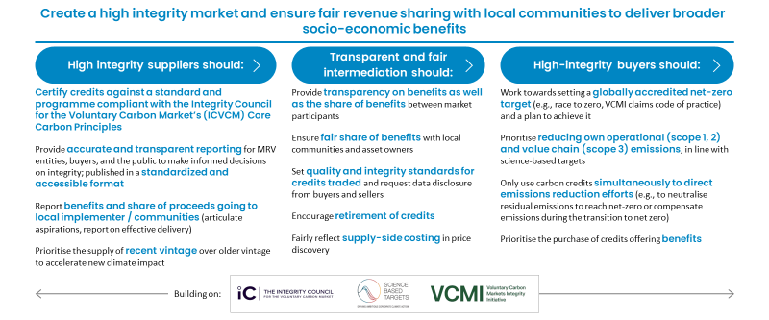

Finally, note that this chapter has only covered action programmes that were prioritised over the past year based on where ACMI’s support had the greatest potential to drive impact. See Chapter 2.1 for more information.

2.3. ACMI’s presence in key events

In the past year, ACMI has partnered with more than 30 organisations and used its platform to host headline events, thus helping build a positive African carbon market narrative. ACMI’s participation in headline events on three continents (Exhibit 2.3.1) has allowed it to highlight and disseminate key messages on the progress of carbon markets, develop critical relationships across the ecosystem and help build a more mature, positive narrative around carbon markets in Africa.

Exhibit 2.3.1: ACMI has had a significant presence at headline events throughout the past year
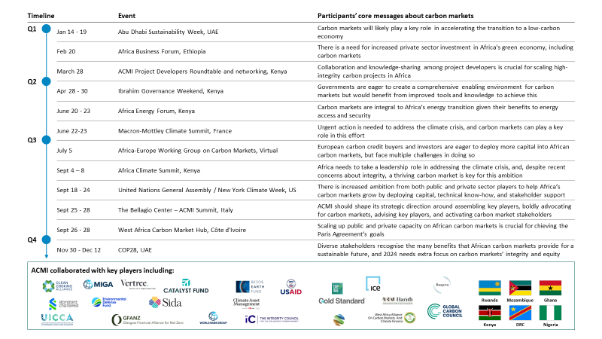

ACMI’s approach to events has been to develop strong partnerships with leading institutions and market players, enabling it to convene stakeholders and become one of the continent’s leading institutions advocating on behalf of carbon markets. Through its partnerships, ACMI has facilitated or co-hosted multiple events with participants from across Africa. These include a project developers’ roundtable (~70 developers), a ministerial roundtable on carbon market regulation (~65 participants) and a buyers’ breakfast (~55 participants), as well as speaking roles in a variety of partner and main-stage events.

Major events with a strong ACMI presence include the Africa Climate Summit, hosted in Nairobi, and the New York Climate Week and the Global Africa Business Initiative (GABI), hosted in New York. These events provided a stage for ACMI and its collaborators to showcase significant achievements and announcements, facilitate high-level discussions and help shape the narrative on African carbon markets as a whole (Exhibit 2.3.2).

At the Africa Climate Summit, ACMI partnered with key stakeholders to establish a prominent presence through three major events and more than ten side engagements. ACMI hosted a main-stage event on day one of the Africa Climate Summit with major players across Africa’s carbon markets. The event allowed several African governments to discuss their carbon market plans and asset managers and investors to announce major advance market signals. The event also provided a platform for the US Special Presidential Envoy for Climate, John Kerry, to speak on the importance of carbon financing as a pathway to achieve the SDGs in Africa. Additionally, a high-level roundtable event allowed Ministers from the Democratic Republic of the Congo, Ghana and Mozambique to reiterate their commitment to developing carbon market regulations in their respective countries (Exhibit 2.3.2). In addition, numerous side events facilitated by ACMI focused on financing and scaling carbon markets, convening local business leaders in Kenya and sharing lessons learned from establishing carbon market regulations.

Exhibit 2.3.2: ACMI held three major events at the Africa Climate Summit
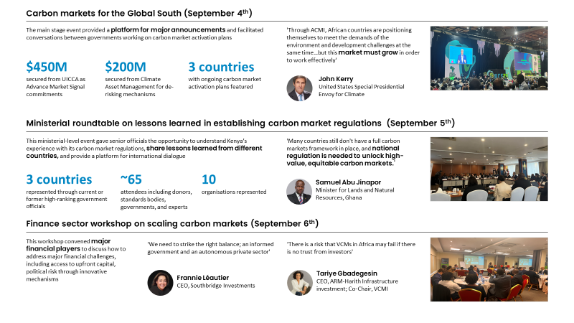

At New York Climate Week and GABI in New York, ACMI hosted numerous major events. ACMI hosted a targeted buyers’ breakfast for major buyers of African carbon credits and facilitated discussion on the benefits and challenges of purchasing carbon credits. ACMI also hosted a main-stage event at GABI, interacting with governments, buyers, project developers, and standards bodies to advocate for African carbon credits. Both events increased ACMI’s engagement with high-profile buyers interested in the emergence of high-quality African carbon credits (Exhibit 2.3.3.).

Exhibit 2.3.3: ACMI hosted major events at New York Climate Week and GABI in New York

2.4. Lessons learned in the past year

Over the past year, ACMI’s engagement with key carbon market players has allowed it to crystallise its understanding of the challenges faced in developing robust African carbon markets. ACMI refined its view of the landscape by engaging with over 20 African countries and 400 carbon market players across the value chain. As a result, clarity has emerged around ten major challenges that need to be addressed, listed in Exhibit 2.4.1.

Exhibit 2.4.1: Africa’s carbon markets face ten core challenges across the value chain
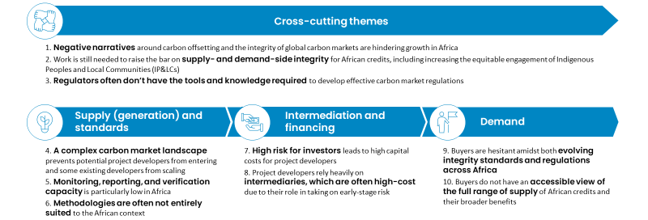

In light of these challenges and stakeholder feedback, ACMI has produced an updated view of how it can most effectively play a role in scaling African carbon markets. There are three key lessons that ACMI has absorbed around its unique role, which are detailed below.

First, ACMI is well positioned to advocate for African carbon markets, thereby promoting a balanced narrative and a high bar on integrity across supply and demand for African credits. Current media debates lack a balanced narrative on African carbon markets, and addressing this remains crucial for building confidence and scaling African markets. ACMI welcomes public scrutiny on the integrity of carbon credits (see Chapter 1.1) and firmly believes that evidence-based debates are an important component in the journey towards a more robust and mature market. However, recent negative narratives have focused heavily on the failures in specific projects and have often disregarded the robust evidence of the benefits that African carbon markets can generate (see Chapter 1.2). To promote more balanced narratives, ACMI together with its partner network must continue to advocate for these benefits to be given greater prominence, highlighting efforts being made to unlock them further while rigorously addressing the remaining problems. Additionally, as a collective we should push for a higher bar on integrity, ensuring that Africa is fully included in current global efforts to increase integrity and that the unique aspects of African credits are acknowledged. Furthermore, ACMI and its partners should advocate for increased demand and investment to realise substantial benefits. This includes investment from voluntary markets (for example, businesses buying credits), compliance markets (for example, allowing the use of African credits in national compliance carbon tax schemes, as in Singapore), and Article 6 carbon markets (for example, encouraging foreign governments to buy African carbon credits).

Second, ACMI is well-positioned to convene and coordinate ecosystem players to address core carbon market challenges. ACMI should continue its proactive role in convening players across the value chain. The aim should be to increase the visibility of work being done, identify gaps, attract capital, drive integrity, and build consensus. ACMI can thereby play an impactful role in building momentum behind African carbon markets and unlocking the many benefits they can bring to local communities, people’s health, the broader economy, and green growth (see Chapter 1.2).

Third, ACMI should partner proactively with other non-partisan actors that are engaged in scaling high integrity carbon markets in Africa. Visible, scale and coordinated support from neutral parties will validate that integrity and continental best interests are at the heart of efforts to scale the market.

Fourth, ACMI should be focused, taking into account existing activity from other actors across the landscape. Over the past year, ACMI’s engagement with over 400 ecosystem actors has allowed it to gain a comprehensive perspective on existing activity across the value chain and identify gaps where greater action is needed to unlock benefits (Exhibit 2.4.2).

Exhibit 2.4.1: There is a wide range of activity across the African carbon market value chain, but some gaps for action remain
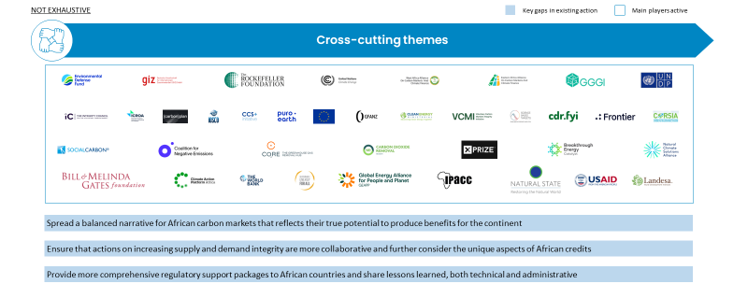
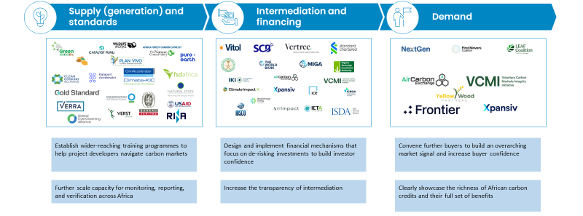

In response to cross-cutting carbon market challenges several organisations and businesses are making progress however, there remain apparent gaps that need to be addressed:

- Negative narratives around global carbon markets hinder growth in Africa. The landscape that is African carbon markets is often misconstrued in the media – a gap remains to advocate for a balanced narrative through an evidence-based, collective effort.
- Work is still needed to raise the bar on supply- and demand-side integrity for African credits. Major global efforts to improve integrity and transparency are underway (see Chapter 1.1). However, more collaboration is needed across African carbon market stakeholders to ensure these standards translate into a higher integrity market in Africa without leaving behind project developers and local communities. This includes elevating the representation of African stakeholders among standards organisations and other bodies that are working on increased integrity. Efforts should also increase engagement with IP&LCs, which is still limited despite many African projects being on or near IP&LC land. Some bodies are working to increase IP&LC engagement, including Natural State, Landesa, ICVCM, and the Indigenous Peoples of Africa Co-ordinating Committee. However, the equity gap still needs to be closed to ensure IP&LCs are sufficiently engaged, supported and have a fair seat at the table.
- Regulators often do not have the tools and knowledge to develop effective carbon market regulations. In response to this challenge, multilateral organisations (for example, the German Agency for International Cooperation (GIZ), USAID, the Global Green Growth Institute, United Nations Development Programme, and the World Bank) and regional organisations (for example, Climate Action Platform - Africa) are providing technical assistance to individual governments on carbon market regulations. They also support governments for trading Internationally Transferrable Mitigation Outcomes (certificates that represent credits’ emission reduction) through Article 6 of the Paris Agreement. However, some conventional support from multilateral organisations has limited coverage for Africa – for example, the World Bank’s Partnership for Market Implementation only operates in five African countries. Additionally, African Article 6 negotiating groups (Eastern Africa and West African Alliances on Carbon Markets and Climate Finance) have formed to establish collective negotiation positions and share insights on international trading. However, these efforts need to be built upon. Countries could benefit from more comprehensive plans that sufficiently address the breadth of complex requirements necessary to make carbon markets successful. Steps must also be taken to better connect and attract technical networks, funding partners and private-sector players to enter or scale within the country’s carbon market ecosystem. Countries would also benefit from increased coordination between donors and those implementing support.

On the supply side, progress is being made, but there still remain gaps to be filled:

- A complex carbon market landscape hinders potential project developers from entering and some existing developers from scaling. Existing efforts to help them navigate the carbon market landscape are largely restricted to specific locations, project types and/or regions. For example, the Clean Cooking Alliance is helping West African project developers scale by launching a curriculum for cookstove carbon credit projects. Strathmore University and GIZ are also designing some project developer curricula for East Africa, and USAID is helping East African smallholder farmers enter the voluntary carbon market. The Nature Conservancy’s Africa Forest Carbon Catalyst is helping forestry-based projects navigate carbon project certification processes, among other offerings. While several general green business accelerators (for example, Catalyst Fund, Climate-KIC ClimAccelerator, Katapult Accelerator, Kenya’s GreenBiz incubator) offer scaling advisory and support services for project developers, this does not extend to helping navigate the complex carbon project requirements. While these targeted efforts are important, there is a need to develop more comprehensive, wider-reaching training programmes for accelerators to deploy in support of carbon project developers.
- Monitoring, reporting, and verification (MRV) capacity is particularly low in Africa. With even the continent’s biggest project developers struggling to access MRV support, this is a major issue. In response, bodies such as Natural State have provided training to increase capacity, and both Verra and Gold Standard provide online training. This progress operates alongside established VVBs with offices on the continent, including TÜV Nord, Rina, and Bureau Veritas. Additionally, standards bodies are also trying to enhance MRVs, as seen in Verra’s efforts to provide deforestation data for MRV use. In parallel, some companies, such as Verst Carbon and Air Impact, have been trying to support project developers with digital tools that support MRV efforts. However, African project developers continue to highlight that capacity is limited, creating bottlenecks and emphasising the need to scale MRV providers further. Efforts to relieve this bottleneck should include further training programmes, increased activity from international MRV providers, and new digital MRV operations for carbon credit projects from local firms in adjacent fields.
- Methodologies are often not entirely suited to the African context. Key certification bodies, including Verra and Gold Standard, have made progress in publishing more Africa-specific methodologies. Verra has released a localised methodology module for its biodiversity certification. Meanwhile, its use of satellite data to provide more accurate baselines for REDD+ projects helps African project developers – who often operate in data-scarce countries – produce high-integrity credits. However, there are still gaps, and stakeholders indicate that more methodologies should be developed to unlock emissions reductions specific to Africa, including fossil fuel generator phase-out, improved efficiency of pastoral agriculture, and savannah fire management.

For the intermediation and financing of African carbon markets, some noticeable gaps need to be addressed:

- High risk for investors leads to high capital costs for project developers. Efforts to support the reduction of perceived investment risks have primarily focused on channelling capital to carbon credit projects, which can increase investor confidence. For example, banks like Standard Chartered have financed nature-based carbon credits on the continent. Similarly, Nigeria’s Sovereign Investment Authority will invest in removals as part of a $50 million joint carbon credit venture with Vitol. Similarly, bodies like Wildlife Works, Conservation International, and the Global Evergreening Alliance work on identifying and financing high-impact carbon projects. However, the scale of investment remains insufficient, and the remaining gap should be bridged through the design of specific financial mechanisms that de-risk investments. Germany’s International Climate Initiative (IKI) is working with three African countries to explore such mechanisms. Vertree and SCB Group have been exploring such mechanisms as well. Additionally, VCMI has partnered with the West African Alliance on Carbon Markets and Climate Finance to advance equitable access to financing through its Access Strategies Toolkit. However, more work is needed. Public and private financial players intending to operate in this space should work to design and develop scalable, context-appropriate de-risking mechanisms collectively. These include tailored insurance products and potentially concessionary capital.
- Project developers rely heavily on high-cost intermediaries. Some entities have worked to standardise contracts and trading regulations (for example, the International Organization of Securities Commissions, International Swaps and Derivatives Association, International Emissions Trading Association, and International Carbon Reduction and Offsetting Accreditation), which may reduce legal costs for intermediation. Additionally, intermediary costs are becoming more transparent through auctions, such as Kenya’s recent auction of carbon credits in June 2023 by the Regional Voluntary Carbon Market Initiative (see Chapter 1.2). Multiple other bodies (for example, Intercontinental Exchange, AirCarbon Exchange and Xpansiv) are interested in promoting auctions and activities in Africa. Furthermore, Climate Action Data Trust’s launch of a comprehensive carbon markets data dashboard will help enhance transparency. However, stakeholders have highlighted that more efforts are needed to increase transparency in intermediation markets to ensure a more equitable field for project developers, which will also see more revenue flowing to local communities. This includes increasing the coverage of benchmark providers, further driving price signals through African exchange traded contracts, and promoting offtake mechanisms, which require upside sharing.

On the demand side, gaps remain for both key challenges:

- Buyers are hesitant amidst evolving integrity standards and regulations across Africa. This challenge relates closely to cross-cutting challenges 2 and 3 and actors addressing those challenges are paving the way to building buyer confidence. Buyers have remained uncertain even as steps to address integrity concerns have gained momentum. Buyer confidence could be boosted by continuing to develop an overarching market signal for demand. Some platforms (for example, LEAF Coalition, Frontier and NextGen) have worked on aggregating demand signals for specific carbon credit types, especially for novel carbon removal methods. However, stakeholders indicate a need for broader market signals, involving more buyers and channelling investments into further project types.
- Buyers do not have an accessible view of the full range of supply of African credits. Major exchanges (for example, Xpansiv and AirCarbon Exchange) help showcase the projects available in Africa on their platforms, and standards bodies (for example, Verra) show projects on their registries. However, stakeholders have voiced concern that information on the breadth of African credits is still not easily accessible and that buyers often do not have visibility over African projects’ uniquely high wider benefits. There is a need for a dedicated showcase of African credits, given their diversity, unique set of benefits, and varied benefit distribution models (see Chapter 1.2).

Based on these key learnings, the sponsors have come together to define an outlook report for the industry that ACMI will support together with its partners (including continuous refinement and re-scoping on outlook opportunities and targets), which is presented in Chapter 3 below. The learnings have helped delineate between areas where other players are better positioned to drive progress and the succinct areas where ACMI, with target partners, is uniquely positioned to act. These areas are outlined below.

3. Indicative outlook for target outcomes over the next 24 months

3.1. A revised approach: Mission, value proposition, and roles

To facilitate ACMI’s continued efforts to build stronger partnerships and institutional capabilities, we have produced a clear mission, vision, and principles to guide our collaborative efforts going forward.

Our Vision is to see high-integrity, transparent carbon markets in Africa scale to drive substantial climate action and deliver considerable co-benefits for the continent’s economy, welfare, and biodiversity. To contribute to the realisation of this vision, ACMI’s Mission, through appropriate partnerships, is to be a powerful non-partisan advocate for African carbon credits, be a trusted neutral advisor, and convene market actors to accelerate the development of African carbon markets. We will act, together with partners, to achieve this mission by aligning with a set of guiding principles. These include: (1) aspire to become established as a standalone institution in the long term to accelerate the development of high-integrity carbon markets – by Africans, in Africa, for Africa; (2) directly deliver targeted initiatives to fill a gap in existing initiatives or in contexts where we are uniquely positioned to advance market success; and (3) activate an alliance by coordinating and accelerating the existing work of partners to deliver on our goals for scaling high integrity carbon markets – being an enabler rather than a competitor.

Drawing on these principles and knowledge gained over the past year since ACMI’s launch at COP 27, ACMI has crystallise how it can most effectively collaborate with others to help scale carbon markets. Our activities will align around delivering on key value propositions. In the first instance, ACMI and its partners will act as advisors to governments on carbon market activation. We will also be a champion for shaping a positive narrative about African carbon markets. On the supply side, we will catalyse high-integrity project development. We will also be a promoter of high integrity-demand and investment in African carbon market projects. In performing our value-creating activities, we will play four core roles, detailed in Exhibit 3.1.1.

Exhibit 3.1.1: The partnership will deliver its value proposition through four core roles
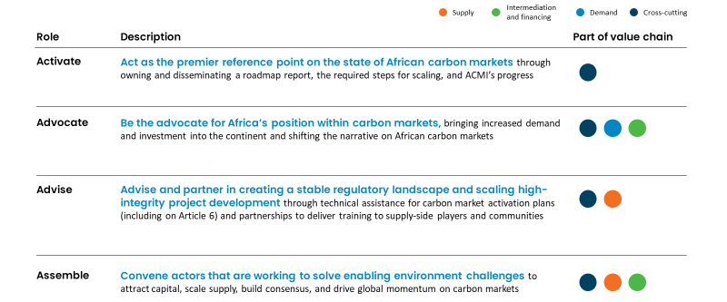

3.2. Key actions to be taken in the African carbon markets

Activate

ACMI will act as and support the emergence of a central reference point for African carbon markets.

Context: Achieving Africa’s ambitious carbon market agenda will require a common understanding of the markets’ challenges and opportunities, including the current state, trends, pain points, priority initiatives and market gaps. While there is a substantial ecosystem of players who provide insight, as of yet, there is no ‘single source of truth’ to anchor around. Given that ACMI is already seen as an important source of knowledge for Africa’s carbon markets, it is well-positioned to become this central reference point.

Action: ACMI is committed to building, with partners, an overarching view of the African carbon market landscape that will inform not only its own activities but also guide the actions of other actors. To help stimulate the landscape, ACMI will release a status and outlook report periodically on the state of African carbon markets that articulates the gaps in current action and the required steps for scaling. This will further the parallel aim of allowing ACMI to build transparency by including a progress update on core programmes.

Target by COP29: Disseminate a status and outlook report on a biannual cycle and spread its insights with the breadth of carbon market players to encourage ambitious, targeted action. Holistic progress update on carbon markets disseminated annually at COP, showcasing progress on key outcomes.

Advocate

Support a compelling narrative for African-sourced credits.

Context: Over the past year, carbon markets have been subject to ongoing debate and scrutiny. There has been a largely negative narrative in media, with evidence on Africa taken from a minority of projects operating below standards, and publications frequently exhibiting ideological opposition to market-based climate solutions. This has made investors and buyers more apprehensive in their support. The market is still not perfect, so collaboration is needed to raise the bar on integrity. However, to redress the imbalance in perceptions on the integrity of African carbon credit projects, ACMI intends to work with its partners to bring mainstream awareness to global efforts to improve integrity and equity, as well as the accompanying benefits carbon markets can create for African communities.

Action: To respond to the need for a balanced and evidence-based narrative, there needs to be a focus on two initiatives:
- Drive a compelling and mature advocacy campaign. Efforts to highlight the potential of carbon markets, elevate evidence-based success, and spotlight the increasing level of market activity. Case studies could be compiled and disseminated to showcase high-integrity, successful projects and emphasise their benefit to African communities. A coordinated campaign of this nature would counter the current negative media narratives and increase the market confidence of buyers, investors, journalists and civil society.
Target by COP29: Secure consistent major publications in key media outlets.
- Promote the development of a high-integrity carbon market in Africa through an active partnership with integrity standards organisations and by fostering stronger collaboration on supply- and demand-side integrity. By engaging with standards governance bodies, project developers, and buyers, ACMI can build more transparency into integrity-building efforts. It can advocate for their wider adoption and help build tangible momentum on this topic to underpin a more positive narrative.
Target by COP29: Hold partners’ convening around two events per quarter to update and highlight on work underway in the carbon markets in Africa.

Generate demand from voluntary buyers, Article 6 markets, and carbon pricing schemes by supporting broader eligibility and increased investment for project development.

Context: In the past year, ACMI has attracted significant interest from companies and investors in African carbon markets. For the advance market signal, companies have collectively signed an intention to purchase $650 million worth of African carbon credits by 2030. In addition, $250 million worth of investments in African carbon credit projects have been committed by 2030 and $400 million worth of traded credits by intermediaries. While these are substantive signals, they occur in the context of slowing global demand for carbon credits due to 2023’s macroeconomic trends, integrity concerns, and a still-nascent regulatory environment. This reinforces the continued need to advocate for a stable stream of demand from voluntary buyers and to translate signals into realised carbon credit purchases. African markets can also benefit from diversifying the sources of demand for credits. This includes a stronger focus on designing fair bilateral Article 6 agreements that protect the long-term interests of African countries and exploring the potential to open up carbon credit eligibility within other countries’ domestic compliance schemes (as is the case with Singapore).

Action: ACMI will contribute to promoting high-integrity demand and investment through five initiatives with partners:
- Influence specific jurisdictions to expand the scope of carbon pricing schemes to include African carbon credits as an option for compliance. African organisations need to host bilateral and roundtable discussions with policy officials to influence policy development for specific schemes (for example, the EU Carbon Border Adjustment Mechanism, EU Carbon Removal Certification Framework and carbon pricing schemes that are already accepting credits, such as in South Africa and Colombia, and Singapore). Greater eligibility for African credits under compliance schemes would lead to increased demand and higher prices for African credits.
Target by COP29: Hold meetings with three active purchaser countries on increasing the eligibility of African credits for compliance obligations.
- Leverage continental partnership with African Union, United Nations Economic Commission for Africa, the African Development Bank together with ACMI to promote continental harmonisation of country/regional positions with regard to carbon markets governance. Regional or continental approaches to leveraging carbon markets will be key to ensuring that all countries benefit from this instrument.
Target by COP 29: Convene a programme geared towards harmonisation of carbon markets approaches with regional bodies and governments
- Build demand for African credits in Article 6 markets. ACMI and its partners will connect host governments to facilitate Article 6 transactions and provide dedicated Article 6 advisory and support on select operationalisation components. They must also convene events that bring together host countries and potential buyers of Internationally Transferred Mitigation Outcomes.
Target by COP29: Three further countries with plans towards closing Article 6 transactions.
- Secure the independent and sustainable management of the Advance Market Signal to encourage buyers to sign up to express their appetite for high integrity African generated credits together with a clear pipeline for investment and offtake opportunities to encourage buyers to convert this signal into realised transactions. ACMI will continue to work to increase the demand signal but focus more heavily on actively tracking and reporting transactions. Advancing the conversion of signals into realised transactions will further enhance market confidence.
Target by COP29: Secure in excess of $1 billion in advance market signals from investors with visible trends in conversions of signals to commitments.
- Showcase African carbon credit projects through a biannually updated project catalogue. This will bring transparency on the breadth of high-integrity projects on the continent that deliver real benefits to African communities and the environment, aligned with ACMI’s integrity principles and its aim to promote a more balanced market narrative.
Target by COP29: Publish a second edition of the African Carbon Credit Showcase.
- Attract new investment signals into African project development. To help unlock access to capital for project developers to scale, ACMI will continue efforts to encourage further investment signals in African project development.
Target by COP29: Secure over $1 billion total in advance market signals, with over 10% converted into genuine transactions.

Advise

Advise countries from a neutral standpoint on carbon market activation, including issues around regulation and Article 6.
Context: African carbon credit projects encounter regulatory hurdles due to a complex and uncertain landscape. Regulations have not yet been developed in many African countries, and some early movers have made policy decisions that have led to reported negative impacts on private-sector interest and investment viability (see policy developments in Exhibit 2.2.1). In addition, complexities have arisen in cases where countries have designated carbon rights as being state-owned, requiring private developers to get approval for all credit transactions – even though African landowners often lack formal land titles and depend on communal or informal tenure customs. These uncertainties cause hesitation and reluctance among investors and require urgent resolution. ACMI has been proactive in this area, working with Kenya and Mozambique to develop CMAPs. These plans are designed to offer multifaceted support, including setting national carbon credit ambitions, integrating carbon markets into broader climate strategies, defining effective regulations and incentives, and establishing plans to activate the local market ecosystem.

Action: ACMI and partners will continue to support governments in market activation through two initiatives:
- Give technical assistance to single countries or country groups on carbon market legal and policy framework implementation / operationalisation. This will facilitate scaling up voluntary and compliance markets, and Article 6 transactions. ACMI with partners will continue to deploy the blueprint tool or similar mechanics to guide priority and competitiveness evaluation and commensurate frameworks needs with individual countries through partners, particularly donors, and give thematic technical assistance to groups of countries to aid the development of a clear, stable regulatory landscape. Advisory support will ensure that governments have sufficient technical understanding to make informed regulatory decisions.
Target by COP29: Regulatory development underway in a further four to six countries – delivered by both ACMI and other partners, with over 10 additional countries engaged through group technical assistance programmes.
- Build a healthy pipeline of countries interested in developing effective regulations by coordinating knowledge-sharing events. Interested parties must broaden the group of African countries working on carbon market activation by organising events – for Ministers and technical government officials – to build momentum and share lessons from other countries.

Support scaling high-integrity, equitable project development through partnerships.
Context: High-integrity credits begin with high-integrity suppliers and methodologies that are set up to create impact at scale. Currently, numerous issues constrain this scenario in the African context:
- There is a lack of project developers, and existing ones are mostly very small (producing less than 3 MtCO₂e per year). Less than 200 project developers were active in the past decade across Africa, most of which operate a single project in a single country. If the supply of African carbon credits is to scale significantly over the next few decades, these project developers will need to scale, too.
- The validation and verification process for African projects is costly and time-consuming. It takes more than two years from a project’s start date to issue and sell the first credit. Additionally, these services are delivered by companies outside Africa, resulting in high costs for project developers, language barriers, and a lack of local market understanding.
- Numerous challenges hinder the equitable community engagement of IP&LCs, who are vital stakeholders in carbon crediting projects. Information asymmetry often means IP&LCs are insufficiently equipped to establish the transparency and safeguarding mechanisms needed to ensure accountability for equitable outcomes.
- Existing carbon credit methodologies often do not fit the African context. They struggle to measure and monitor projects with fragmented assets, limited infrastructure, and common technology constraints. There are also key methodology gaps in harnessing Africa’s decarbonisation opportunities (for example, fossil fuel phase-out and livestock). In total, we estimate this gap renders inaccessible a total of 140 MtCO₂e in credit generation and decarbonisation.

Action: Supporting high-integrity, equitable project development through four initiatives:
- Increase the scale of developers and resulting supply. ACMI developing and hosting a “Carbon Knowledge and Innovation Hub” (“Carbon Hub”) to provide basic carbon project information to those interested or at the beginning of developing projects through a “one-to-many” approach. In this context, building a central repository of information and tools to enable project developers to access the market and have the support to scale effectively.
- Target by COP29: Complete operationalisation of the Carbon Hub, bringing together relevant information for all sectors, and supporting data aggregation from across partners.
- Increase validation and verification capacity. Based on work already delivered to develop a concept design and partnership identification, ACMI and partners will support the deployment of an auditor training programme. This will be deployed in cohorts by partners and followed by on-the-job training. It aims to reduce the time new auditors need to train before working autonomously, making it easier for African VVBs to scale. Further support must be undertaken by and through partners to reach the required scale.
Target by COP29: Training programmes for auditors funded and in progress
- Facilitate equitable engagement for IP&LCs. Grassroots IP&LC training on carbon markets is incredibly important to ensure a level playing field and better benefit sharing. Such training will offer IP&LCs tools and information to enable equitable market participation (for example, free and prior informed consent, safeguarding principles, benefit-sharing mechanisms, and carbon rights). Leverage work undertaken to design a programme and identify delivery partners.
Target by COP29: Secure funding and delivery partners to support well-informed decision and effective and equitable free prior and informed consent by IP&LCs.
- Support the development of methodologies that unlock Africa-relevant mitigation opportunities. ACMI will continue to support new methodologies and proof-of-concept pilots in collaboration with partners, starting with ongoing work on fossil fuel generator set phase-out and livestock methodologies. ACMI has created a fossil fuel generator phase-out methodology concept, which welcomes partner support. Further work is also needed to ensure that methodologies are relevant to the African context and that new methodologies are developed to realise the full potential of carbon finance for the region.
Target by COP29: Create one new carbon credit methodology and have two methodology pilots underway.

Assemble

Coordinate and convene actors seeking to enable an effective African carbon market environment.

Context: To maximise impact on the continent, ongoing work of other actors across the value chain must be highlighted and not duplicated. Thus, coordination and convening is incredibly important to ensure full effectiveness continue to play a valued role as a stakeholder convenor – highlighting important topics and increasing the prominence of African carbon markets on the global climate agenda.

Action: ACMI will continue to convene actors through four initiatives:
- Promoting the establishment of project developer communities. This will foster peer-to-peer learning, knowledge exchange, and mutually beneficial partnerships. ACMI will deploy this through a community initiative centred on a social media platform and in-person gatherings.
Target by COP29: Bring visibility to project developer platforms that are put in place, to incentivise participation and community engagement.
- Engage with and Convene the wider donor community to ensure long term support to scaling high integrity carbon markets in Africa
Target by COP29: Organise donor roundtables on carbon markets at 3 key events
- Convene stakeholders that are already supporting the development of regulatory frameworks in carbon markets. Key organisations need to come together to help translate international lessons into the African context by engaging and convening institutions working on carbon market regulation and harmonisation, for example, donors, multilateral development banks, the UN, and think tanks.
Target by COP29: Convene two high-level events on global regulation to engage with institutions working on regulatory frameworks.
- Convene and partner with financial institutions to facilitate the development of innovative de-risking structures. The market must come together to design and implement de-risking financial instruments.
Target by COP29: Organise at least one high level roundtable for major financial institutions.

4. A call to action
In a rapidly evolving global carbon market, collaboration is key for helping Africa navigate the path to a prosperous, sustainable future. ACMI’s aim is to help guide the market on this path in a high-integrity manner by assembling carbon market players, boldly advocating for carbon markets, advising public- and private-sector actors, and activating players to raise their ambitions. This can unlock billions in climate finance for African economies while expanding energy access, creating jobs, improving health, protecting biodiversity, and driving climate action. However, achieving this sustainable and prosperous future is a highly complex task, and collaboration is crucial. ACMI is thus actively seeking to activate partnerships across the carbon market value chain so that key initiatives outlined in the previous chapter can deliver credible outcomes

This report provides players with the knowledge and perspectives to navigate African carbon markets as a foundation for a clear call to action. As part of ACMI’s commitment to transparency, this report aims to help all players navigate the complexities of African carbon markets through clear and comprehensive insights into the market and its trends, challenges, opportunities, and gaps in action. Based on this knowledge foundation, the report calls upon all stakeholders to actively engage and collaborate to support and shape Africa’s carbon markets (Exhibit 4.1).

Exhibit 4.1: ACMI calls upon all stakeholders to collaborate and help scale African carbon markets with high integrity and ambition
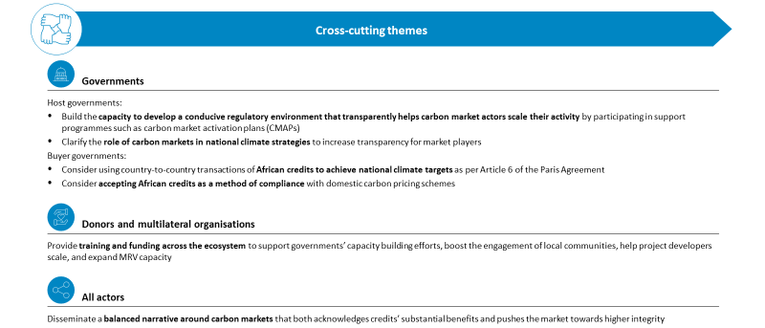
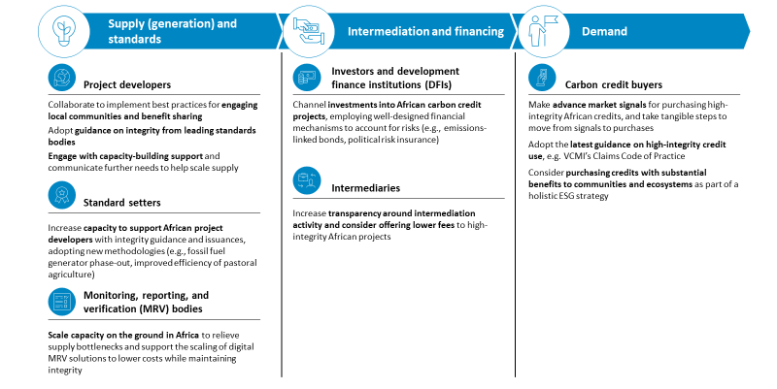

The vision for Africa’s carbon market is ambitious and clear, aspiring to achieve wide-reaching, diverse benefits for people and the planet. The fulfilment of this vision relies on our collective commitment and proactive collaboration. With this status and outlook report, we look forward to working jointly to support Africa’s future as a global leader in low-carbon development.

Glossary
Article 6: A section of the Paris Agreement that addresses international cooperation in achieving climate goals. It provides a framework for voluntary cooperation between countries in the implementation of emission reduction activities.
Adaptation projects: Initiatives addressing the impacts of climate change and building resilience in vulnerable communities.
Avoidance projects: Along with removal, one of the two major types of carbon credits. Avoidance projects prevent the release of greenhouse gases that would otherwise be emitted, such as by preventing deforestation in an area with a high rate of logging.
Baseline Emission Levels: The reference point against which emission reductions are measured, providing a benchmark for assessing the impact of carbon market projects.
Blue carbon: Carbon captured and stored by coastal and marine ecosystems, such as mangroves and seagrasses, contributing to climate mitigation efforts.
Carbon registry: A centralised system for recording, tracking, and verifying the issuance and transfer of carbon credits, ensuring transparency and accountability.
Climate finance: Financial support provided to projects and initiatives addressing climate change, including those in the carbon markets.
Climate neutral: Achieving a state where the net greenhouse gas emissions associated with an entity, activity, or product have been fully balanced, resulting in no net impact on the climate. Carbon neutrality refers to the same concept, with reference to only CO₂.
Conference of the Parties (COP): An international climate conference convened by the United Nations Framework Convention on Climate Change (UNFCCC), where representatives from member countries gather to assess progress in dealing with climate change, negotiate agreements, and set future targets. COP meetings play a crucial role in shaping global climate policies, particularly those related to Article 6 of the Paris Agreement.
Conference of the Parties (COP): An international climate conference convened by the United Nations Framework Convention on Climate Change (UNFCCC), where representatives from member countries gather to assess progress in dealing with climate change, negotiate agreements, and set future targets. COP meetings play a crucial role in shaping global climate policies, including those related to carbon markets in Africa.
Decentralised renewable energy (DRE): Energy systems that utilise locally available, renewable resources, promoting energy access and sustainability in remote or rural areas.
Emissions trading system (ETS): There are different types of ETS. In a ‘cap-and-trade system’ regulators set a fixed upper limit on total emissions (‘cap’) and auction or distribute allowances (typically one allowance grants the right to emit one tonne of CO2e). Under a ‘baseline-and-credit system’ each individual entity is required to reduce emissions at a certain rate. Companies that reduce emissions faster than they are obliged to can earn ‘credits’ which they can sell to entities which do not meet their required obligations.
Indigenous peoples and local communities (IP&LCs): typically, ethnic groups who are descended from and identify with the original inhabitants of a given region, in contrast to groups that have settled, occupied or colonised the area more recently.
Leakage: Risk to manage in the design of carbon credit methodologies. Describes situations when the direct impact of a carbon reduction activity is offset by its indirect impacts. For example, protecting a forest from logging could lead to an increase in logging in surrounding forests, negating the intended effect.
Monitoring, Reporting, and Verification (MRV): A process ensuring accurate measurement and reporting of greenhouse gas emissions, crucial for verifying emission reduction activities in carbon markets.
MtCO₂e: Megatonne of CO₂ equivalent. Standardised unit for greenhouse gases that expresses all emissions in terms of the amount of CO2 with equivalent global warming potential.
Nationally Determined Contributions (NDCs): Country-specific climate action plans submitted under the Paris Agreement, outlining emission reduction targets and adaptation strategies.
Nature based solutions: Projects that use natural landscapes to mitigate climate change, often while providing biodiversity co-benefits. Includes forestry, agriculture, and blue carbon projects.
Net zero: A condition in which the total greenhouse gas emissions produced are equal to the amount removed or offset, effectively balancing the carbon footprint and mitigating the impact on the climate.
Paris Agreement: Landmark 2015 international treaty on climate change. Article 6 of the Paris Agreement covers voluntary international cooperation, including carbon trading. Additional details on the implementation of Article 6 were agreed to at COP26 in Glasgow.
Reducing emissions from deforestation and forest degradation (REDD+): Framework for emissions-limitation programs focused on preventing deforestation that was negotiated under the United Nations Framework Convention of Climate Change (UNFCCC). REDD+ credits are not allowed in the Clean Development Mechanism but are common in the voluntary carbon markets. SBTi
Sustainable Development Goals (SDGs): A set of 17 global goals established by the United Nations to address social, economic, and environmental challenges, including climate-related objectives.
Validation and Verification Body (VVB): Independent entities responsible for validating and verifying that emission reduction projects adhere to specific standards and criteria in carbon markets.
Internationally Transferred Mitigation Outcomes (ITMOs): Internationally traded carbon credits resulting from emission reduction activities transferred between countries, fostering international collaboration in achieving climate goals.

Contact us:
Website: africacarbonmarkets.org
Email: info@africacarbonmarkets.org

‘By developing a robust, transparent and sustainable mechanism through which a carbon credits market can yield attractive income and development opportunities for communities at the frontlines in the fight against climate change, we will align incentives among polluting producers and sequestration enterprises to achieve net zero industrialisation and shared green prosperity.’ – H. E. William Ruto, President of Kenya

References

Includes carbon credits traded through voluntary carbon markets and Article 6 of the Paris Agreement.
Data includes carbon credits traded through voluntary carbon markets and Article 6 of the Paris Agreement.
In order for credits to be valid, they must be generated under implementation agreements that Singapore has signed with the projects’ host countries. As of mid-October 2023, Singapore has signed implementation agreements with Ghana and Vietnam, while similar agreements are in progress in over 10 more countries.
Data includes carbon credits traded through voluntary carbon markets and Article 6 of the Paris Agreement.
The World Economic Forum’s development of a biodiversity credit model was a promising source of progress on Action Programme 11, and Action Programme 8 was addressed by recent regulatory developments, in particular the European Union’s Green Claims Directive, which decreased the role of carbon neutral commodities.
The development of country carbon market activation plans (CMAPs) (Action Programme 1) was initially listed as a supply-side programme in the 2022 Roadmap Report. However, achievements related to CMAPs are listed as cross-cutting throughout this document, given their potential to also increase demand and streamline financing.
As of March 2023.
This includes future issuances of existing projects and projects designed but not verified. Project integrity is self-reported by project developers given the scale of the showcase.
Unique aspects of African carbon credits include the unique emission-reduction opportunities present on the continent (for example, phasing out fossil fuel–based generator sets) and the unique benefits that African projects can provide (for example, high health benefits from pollution-reducing cookstove projects).
Gold Standard offers trainings through its SustainCERT Academy. Verra offers free webinars on YouTube for VVBs.
UN (2023). ‘Secretary-General’s video message for press conference to launch the Synthesis Report of the Intergovernmental Panel on Climate Change’.
African Union (2023). ‘The African Leaders Nairobi Declaration on Climate Change and Call to Action’.
African Union (2023). ‘The African Leaders Nairobi Declaration on Climate Change and Call to Action’.
Notably: The Guardian (2023). ‘Revealed: more than 90% of rainforest carbon offsets by biggest certifier are worthless, analysis shows.’ and The New Yorker (2023). ‘The great cash-for-carbon hustle.’
See, for example, Calyx Global (2023). ‘Cooking up Quality: Carbon credits from efficient cookstove projects face integrity issues worth fixing.’
Data extracted from VCS, GS, CAR, ACR registries at the start of Oct 2023. Excluding Gold Standard-labelled CERs used for meeting compliance targets and Planned Emission Reduction units (PERs). Incl. CAR and ACR cancellations.
See, for example, The Guardian (2023). ‘Greenwashing or a net zero necessity? Climate scientists on carbon offsetting.’
Mongabay (2023). ‘Control of Africa’s forests must not be sold to carbon offset companies (commentary).’
See, for example, LSE (2023). ‘Article 6.2 carbon markets in Ghana: a bright future for a shadowy business.’
Sylvera (2023). ‘The State of Carbon Credits 2023.’ Over-the-counter credits are credits traded directly between two parties, representing roughly 75% of all credits traded.
Kenyan Presidency (2022). ‘Remarks by His Excellency William Samoei Ruto at the Launch of African Carbon Markets Initiative (ACMI) at COP27.’
Sylvera (2023). ‘Carbon Credits: Permission to Pollute, or Pivotal for Progress?’
Ecosystem Marketplace (2023). ‘2023 All in on Climate: The Role of Carbon Credits in Corporate Climate Strategies.’ Value for the median business.
Gold Standard (2023). ‘Our Work – Consultations’. Verra (2023) ‘Consultations.’
B&FT Online (2023). ‘Ofori-Atta rallies African countries to achieve 40% carbon credit by 2030.’
Based on issuance data extracted from VCS, Gold Standard, CAR and ACR registries and price data from Ecosystems Marketplace (2022). ‘Ecosystem Marketplace’s State of the Voluntary Carbon Markets 2022 Q3’.
Sylvera (2023). ‘Carbon Credits: Permission to Pollute, or Pivotal for Progress?’
Ecosystem Marketplace (2023). ‘2023 All in on Climate: The Role of Carbon Credits in Corporate Climate Strategies’. Value for the median business.
World Bank (2023). ‘State and Trends of Carbon Pricing 2023’.
The green transition will require roughly $4 trillion to $5 trillion in investment, based on estimates from World Economic Forum (2023). ‘Financing the Transition to a Net Zero Future’.
Carbon Market Watch (2023). ‘FAQ: Everything you need to know about Article 6 at COP28.’
Carbon Risk (2023). ‘Is the VCM a trillion dollar business opportunity?’ Includes voluntary carbon markets and credits traded under Article 6 of the Paris Agreement.
Reuters (2023). ‘Carbon credit market confidence ebbs as big names retreat’.
Carbon Market Watch (2023). ‘Secretive Intermediaries: Are carbon markets really financing climate action?’
Sylvera (2023). ‘The State of Carbon Credits 2023’.
Carbon Market Watch (2023). ‘Secretive Intermediaries: Are carbon markets really financing climate action?’
Based on CBL Global Emissions offset credits traded via Xpansiv CBL markets (2023). Note that peak prices were largely driven by blockchain interventions in carbon markets in 2021-22, as indicated by Time (2022). ‘The Crypto Industry Was On Its Way to Changing the Carbon credit Market, Until It Hit a Major Roadblock’.
Data extracted from VCS, Gold Standard, CAR and ACR registries at the start of October 2023. Excluding Gold Standard–labelled CERs used for meeting compliance targets and Programmatic Emission Reductions. Including CAR and ACR cancellations.
Notably, The Guardian (2023). ‘Revealed: more than 90% of rainforest carbon offsets by biggest certifier are worthless, analysis shows’; The New Yorker (2023). ‘The great cash-for-carbon hustle’.
See, for example, Calyx Global (2023). ‘Cooking up Quality: Carbon credits from efficient cookstove projects face integrity issues worth fixing’.
Carbon Pulse (2023). ‘Verra bins UN rice farming carbon credit blueprint after review’.
Mongabay (2023). ‘Control of Africa’s forests must not be sold to carbon offset companies (commentary).’
See, for example, The Guardian (2023). ‘Greenwashing or a net zero necessity? Climate scientists on carbon offsetting’.
See, for example, LSE (2023). ‘Article 6.2 carbon markets in Ghana: a bright future for a shadowy business.’
International Monetary Fund (2023). ‘Global recovery remains slow, with growing regional divergences and little margin for policy error’.
Straits Times (2023). ‘Singapore sets eligibility criteria for carbon credits that can be used to offset carbon tax’.
Kluwer International Taxes (2022). ‘Taxing carbon offset credits’.
SBTi (2023https://sciencebasedtargets.org/resources/files/SBTiMonitoringReport2022.pdf). ‘SBTi Monitoring Report 2022’. Carbon Pulse (2023). ‘Over 1,000 new firms enter voluntary carbon market in 2023 -analysts’. United Nations Environment Programme (UNEP) (2023). ‘Article 6 Pipeline’. Data until 31 October. Reflects bilateral agreements that have been signed between national governments related to cooperation under Article 6. The agreements have differing objectives and legal statuses. For Japan, bilateral agreements are intended to establish the Joint Crediting Mechanism, which includes activities that predate the Paris Agreement. For Australia, it includes Australia’s partnerships with Fiji and Papua New Guinea announced under the Indo-Pacific Carbon Offsets Scheme.
SBTi (2023https://sciencebasedtargets.org/resources/files/SBTiMonitoringReport2022.pdf). ‘SBTi Monitoring Report 2022’.
Carbon Pulse (2023). ‘Over 1,000 new firms enter voluntary carbon market in 2023 -analysts’.
Sylvera (2023). ‘The State of Carbon Credits 2023’.
Climate Wire (2023). ‘“Without this, we don't make it.” Kerry promotes carbon credit plan’.
African Business (2023). ‘How can Africa get a fair price for its carbon credits?’
Data extracted from VCS, Gold Standard, CAR and ACR registries at the start of October 2023. Excluding Gold Standard–labelled CERs used for meeting compliance targets and Programmatic Emission Reductions. Including CAR and ACR cancellations.
See ACMI Roadmap Report 2022.
Data extracted from VCS, Gold Standard, CAR and ACR registries at the start of October 2023. Excluding Gold Standard–labelled CERs used for meeting compliance targets and Programmatic Emission Reductions. Including CAR and ACR cancellations.
Bloomberg (2023). ‘Faulty Credits Tarnish Billion-Dollar Carbon Offset Seller’.
Bloomberg (2023). ‘Rule That Rocked Global Carbon Market Softened in Zimbabwe’.
Data extracted from VCS, Gold Standard, CAR and ACR registries at the start of October 2023. Excluding Gold Standard-labelled CERs used for meeting compliance targets and Programmatic Emission Reductions. Including CAR and ACR cancellations.
UNEP (2023). ‘Article 6 Pipeline’. Data until 31 October. These agreements usually involve memoranda of understanding, trade deals (particularly with Korea) or bilateral contractual agreements (particularly with Switzerland).
See ACMI Roadmap Report 2022.
Data extracted from VCS, Gold Standard, CAR, ACR and Plan Vivo registries; also based on analysis of news articles and company websites. Note that South Pole has cut ties with some of its largest carbon credit projects, recently removing associations with the Kariba megaproject following recent allegations of over-crediting – see, for example, Reuters (2023). ‘Carbon offset firm South Pole cuts ties with Zimbabwe forest project’.
Includes on-grid renewables, which comprised 95% of African renewable carbon credit issuances in the past year. Note that the supply of on-grid renewables is on a downward trajectory, while off-grid renewables are growing – for these two categories, supply decreased and increased by 42% and 41%, respectively, in the past year alone.
United Nations Africa Renewal (2023). ‘How Kenyan coastal villagers are cashing in on carbon credits’.
Farm to Market Alliance (2023). ‘AI-powered soil carbon project launched in East Africa to support smallholder farmers’.
Carbon Pulse (2023). ‘UK-funded initiative to pilot biodiversity crediting in Uganda, Zambia’.
Presidency of Kenya (2023). ‘Remarks by His Excellency Hon. William Samoei Ruto, PhD, CGH, President of the Republic of Kenya and Commander-in-Chief of the Defence Forces, at the opening of the Africa Climate Summit Ministerial Conference’.
From speaking on ACMI at Africa Climate Summit 2023.
ACMI Roadmap Report 2022.
Based on share of total African issuances in the past 24 months. Data extracted from VCS, Gold Standard, CAR and ACR registries at the start of October 2023. Excluding Gold Standard–labelled CERs used for meeting compliance targets and Programmatic Emission Reductions. Including CAR and ACR cancellations.
From 2022 Roadmap Report. Calculation based on VCS, Gold Standard, ACR, CAR and Plan Vivo registries; United Nations Framework Convention on Climate Change; VCM model; World Bank; ease of doing business rankings; International Energy Agency; S&P Global Platts; Enerdata; McKinsey Nature Analytics; Climate Action Platform for Africa; Griscom et. al. (2020); Food and Agriculture Organization; Biodiversity Research Institute; Intergovernmental Science-Policy Platform on Biodiversity and Ecosystem Services; CGIAR; and Global Alliance for Climate-Smart Agriculture.
World Bank (2019). ‘The Dirty Footprint of the Broken Grid’.
Verra (2023). ‘Verra biodiversity methodology to provide global framework with localised modules’.
Reuters (2023). ‘Verra vows to turn over new leaf using AI and more credible methodology for carbon offsets’.
For reports on Zimbabwe, see Bloomberg (2023). ‘Rule That Rocked Global Carbon Market Softened in Zimbabwe’; France24 (2023). ‘Zimbabwe's carbon credit takeover spooks locals, investors’. For reports on Tanzania, see Africa Intelligence (2023). ‘Private sector pushes Samia to revise onerous carbon credit rules’; Carbon Pulse (2023). ‘Tanzania faces protests over “unprecedented” fees for voluntary carbon projects’.
Kenyan Presidency (2022). ‘Remarks by His Excellency Hon. William Samoei Ruto, PhD, CGH, President of the Republic of Kenya and Commander-in-Chief of the Defence Forces, at the launch of the Africa Carbon Markets Initiative (ACMI) at COP 27.’

